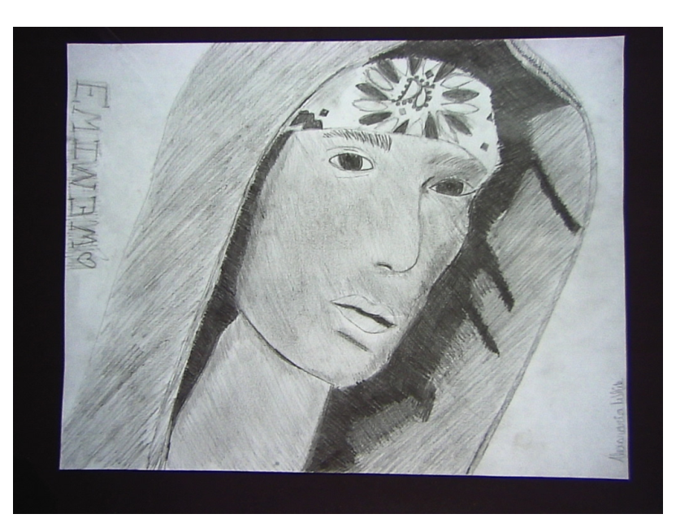
Eminem
By: Alexandria White

