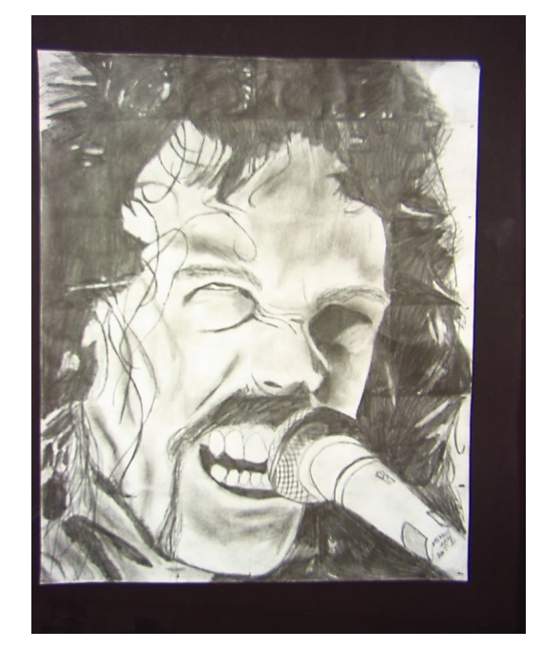
James Hetfield (Metallica)
By: Mitchell Skidd

