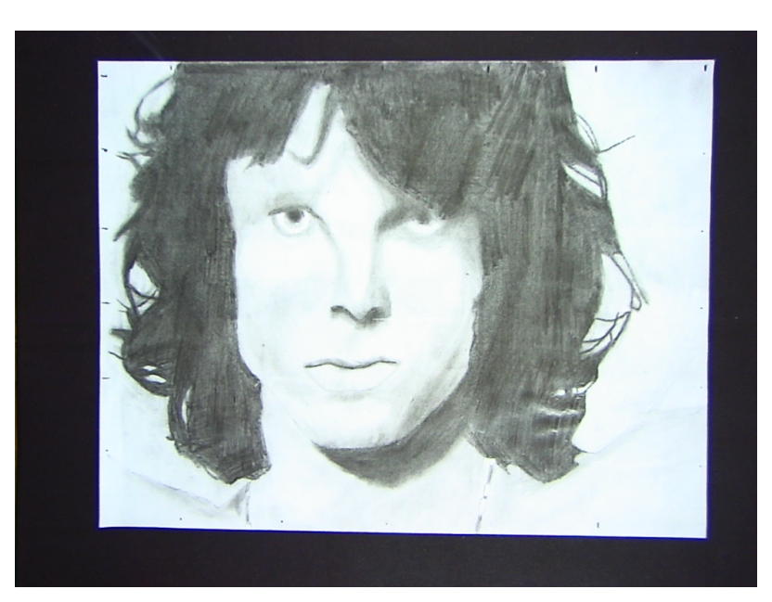
Jim Morrison (The Doors)
By: Michael Dick

