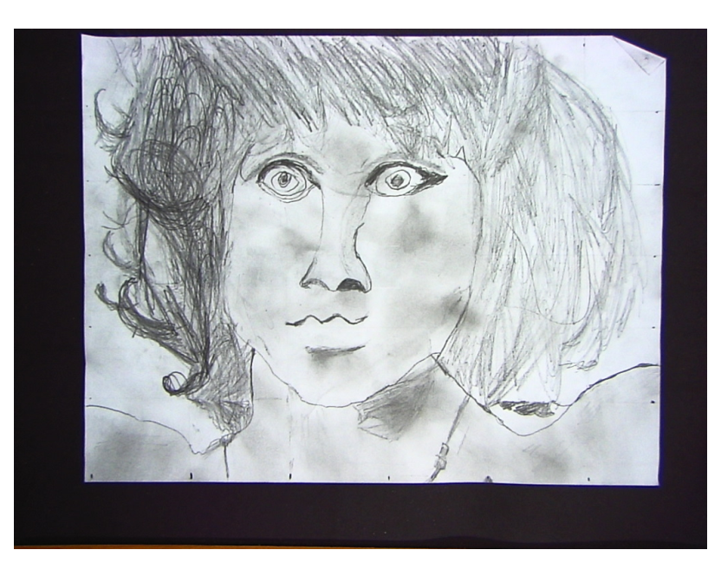
Jim Morrison (The Doors)
By: Cail Morris

