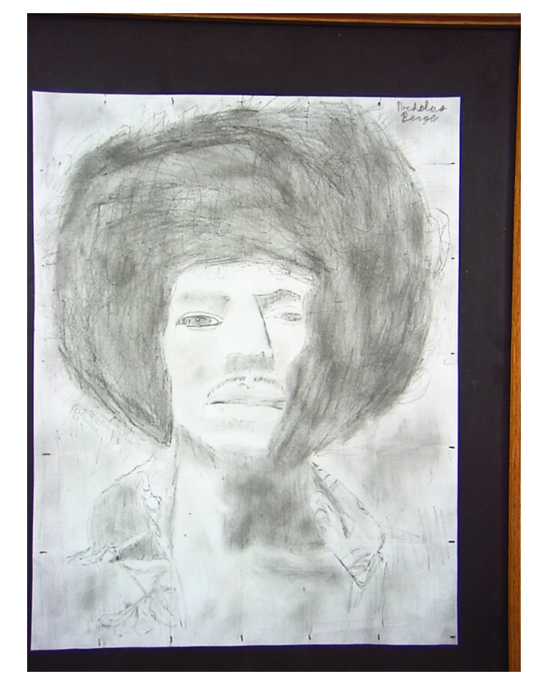
Jimmy Hendrix
By: Nicholas Berge

