English 123 Exam Review
Short Stories
You should familiarize yourself with the short stories we read this semester:
The Necklace
The Pardoner’s Tale
The Cask of Amontillado
The Black Cat

Be sure to know how to do a plot diagram. Focus on the 5 points of a short story.
Of Mice and Men
-Characters
-Themes
-Plot

Poetry
Be able to explain what each of the following are and give examples.
Alliteration
Assonance
Allusion
Couplet
Hyperbole
Imagery
Metaphor
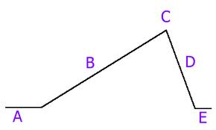
Onomatopoeia
Personification
Simile

Plot Diagram
5 parts of a plot diagram
5 points of a short story (CATSP)
Conflicts
Types of characters (protagonist and antagonist)

