Review for Test #4: Protista, Fungi and Plantae
Terms to Know:
Protists  Zooflagellates  Ciliates  Sporozoans  Sarcodines  Amoeba  Pseudopod  Paramecium  Cilia  Euglena  Eyespot | Fungi  Chitin  Hyphae  Mycelium  Fruiting body  Plantae  Cellulose  Chlorophyll  Non-vascular plants  Mosses  Liverworts  Hornworts | Seedless Vascular Plants  Xylem  Phloem  Lignin  Roots  Leaves  Stems  Ferns  Fronds  Club mosses  Horsetails | Gymnosperms  Angiosperms  Flowers  Fruits  Pollen  Cotyledon  Monocot  Dicot  Anther/Filament  Stigma/Style/Ovary  Ovule

Review Questions:
- Pg 545: #1,2,7,12, 15
- Pg 575: #1,5,6,9,24,25
- Compare the structures used for movement in the amoeba and the paramecium.
- Study diagrams of the Amoeba and Paramecium.
- What is the term for the part of the mushroom that we can see above the ground?
- Study diagram of the mushroom.
- What are the four divisions of plants? How are they separated?
- Why are ferns able to grow taller than mosses?
- How are monocots and dicots different?
- What are the two types of vascular tissue in plants? Describe the function of each.
- Study diagram of the flower.
- What are the three groups of Byrphytes (non-vascular plants)
- What are the three groups of seedless vascular plants

Review for Test #4: Answer Key
Pg 545
1:A
2:B
7:C
12: Hyphae are tiny filaments that are only one cell thick, whereas a mycelium is a thick mass composed of many hyphae tangled together
15: Spores must land in a favorable environment. There must be the proper combination of temperature, moisture and food.

575:
1:B
5:D
6:B
9:C
24:Fruits attract and are eaten by animals that spread the seeds enclosed in the fruits. This increases the range that angiosperms can inhabit.
25: Moncots have leaves with parallel veins, dicots have leaves with branched veins.

3: Amoeba= pseudopods- cytoplasmic projections that caused organism to move
Paramecium= cilia- tiny hair like projections that surround the organism and move in rhythmic patterns to move.

5:Fruiting body

7: Non-vascular plants- does not contain vascular tissue
Seedless Vascular plants- contains vascular tissue but does not have seeds.
Gymnosperms- contains vascular tissue and seeds are “naked”
Angiosperms- contains vascular tissue and seeds are enclosed.

8: Ferns contain vascular tissue and is able to transport water up the plant.
9:
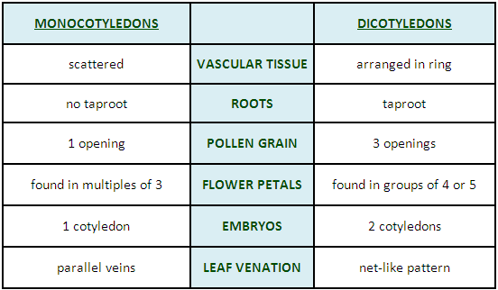

10:Xylem= brings water up from the roots to the leaves.
Phloem= transports solutions and nutrients throughout the plant.

12:Mosses, Liverworts, and Hornworts
13: Club Mosses, Horsetails, Ferns

