Review for Test #3
Terms to Know:
Cell Membrane  Concentration  Osmosis  Hypotonic  Isotonic  Hypertonic  Endocytosis  Phagocytosis  Cellular Respiration  Cell Wall  Diffusion | Facilitated Diffusion  Exocytosis  Mitochondria  Chloroplast  Lipid Bilayer  Equilibrium  Active Transport  Pinocytosis  Glycolysis  Photosynthesis

Review Questions:
- Pg 217:#2,4,6,7,16
- Pg 237: #1-4,14
- Why is the cell membrane considered to be a lipid bilayer?
- Describe the process of diffusion.
- What is the relationship between osmosis and diffusion?
- Distinguish between hypertonic, hypotonic and isotonic solutions.
- Describe what happens to a cell when placed in the following solutions:
a) hypertonic b) hypotonic c) isotonic
- How does facilitated diffusion differ from diffusion?
- Explain the difference between facilitated diffusion and active transport. Be sure to indicate whether or not each process requires energy.
- Distinguish between endocytosis and exocytosis.
- Name and describe the two types of endocytosis.
- What is the mitochondrion’s job in the cell?
- What is cellular respiration? Write out the equation associated with it.
- What is the chloroplast’s job in the cell?
- What is photosynthesis? Write out the equation associated with it

Review for Test #3: Answer Key

Pg 217
2:B
4:D
6:A
7:D
16:Carbon dioxide +water----- sugars + oxygen

Pg 237
1:C
2:B
3:B
4:C
14:oxygen + glucose ---- carbon dioxide + water + oxygen

3. Two layers of lipid molecules

4. Movement of particles from an area of high concentration to an area of low concentration

5. Osmosis is the diffusion of water through a selectively permeable membrane.

6. Hypertonic =larger concentration of solute, hypotonic= smaller concentration of solute, isotonic= concentration is same throughout

7. Hypertonic= water from the cell will move out of the cell, possibility of the cell shrinking
Hypotonic= water from the solution will move into the cell, possibility of a burst cell
Isotonic= water will move into and out of the cell at the same rate

8. Facilitate diffusion requires the use of protein transports

9. Facilitated diffusion involves particles moving from high to low concentration and does not require any energy. Active transport involved particles moving from low to high concentration and requires energy (ATP) from the cell.

10. Endocytosis= substances moving INTO the cell
Exocytosis= substances moving OUT OF the cell

11. Pinocytosis= liquid being moved into the cell
Phagocytosis= particles being moved into the cell

12. To provide the cell with energy through the conversion of glucose.

13. Process that releases energy by breaking down glucose in the presence of oxygen.
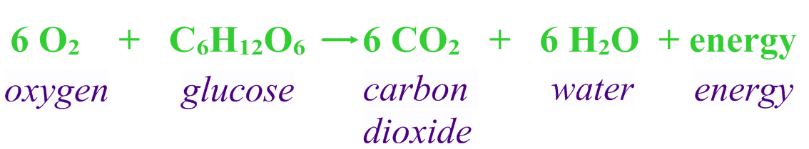

14. To make food (glucose) for the cell through the energy of the sun, water and carbon dioxide.

15. Process that uses the energy from the sun to convert water and carbon dioxide into high energy sugars and oxygen.
