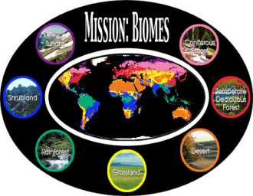
Travel to MY Biome!

Due Date: ________________

Your Job: Your primary goal should be to learn as much as possible about each of the biome types. In order to accomplish this goal , you will prepare a “sales” presentation (commercial, infomercial, brochure) and try to sell a trip to your Biome.

Guidelines:
- Students will work in groups of 2 or 3.
- One biome will be assigned per group. (Random Draw). The list is at the bottom of this sheet.
- Each group will choose one method of presentation:
  - Video
  - PowerPoint presentation-automated
  - Presentation board (like at a trade show)
  - other (subject to approval)
- Each presentation should run no less than 3 minutes and no more than 5 minutes.

Requirements: The following information must be presented:
- Geographic distribution of biome (must clearly show location on world map to guide other student’s maps)
- Key Features of that biome
- Value to humans
- Any recent changes
- Species diversity
  - Overall species diversity (low, medium, high species diversity)
  - Dominant plants and animals (Examples of at least3 plants and 3 animals that are typical of that biome)
- Abiotic features of the biome – must include climate (at least temperature & precipitation)
- Other unique features

Grading
- Grading will be based on accuracy, completeness, creativity, learning value, quality of presentation.
- This project is worth 20 points, and all members of the group will receive the same grade unless there is a clear difference between partners and the work produced. (See Biome Rubric)

Biomes

Terrestrial Biomes | Aquatic Biomes
- Tundra  - Taiga (boreal forest)  - Temperate deciduous forest  - Temperate rainforest  - Tropical rainforest  - Temperate Grassland  - Tropical Savanna  - Desert  - Mountains | - Fresh water (rivers, streams, lakes, ponds)  - Wetland (& estuary)  - Intertidal  - Coral reefs  - Pelagic (open ocean)  - Hydrothermal vents

