- THOUGHTFULLY NOTATE THIS ARTICLE TO SHOW EVIDENCE OF YOUR THINKING THROUGHOUT YOUR READING (this includes using vocab strategies, as well).
- RESPOND TO THE “Food For Thought” SECTION BELOW THE ARTICLE.

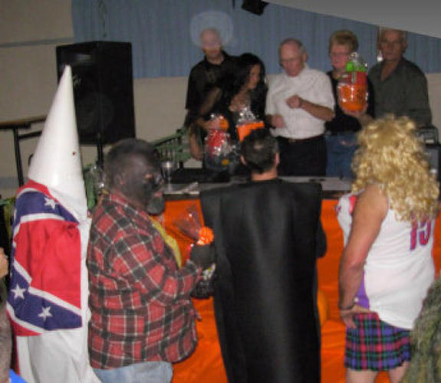
http://www.thestar.com/news/article/884883--kkk-costume-at-canadian-legion-halloween-party-disgusts-many

KKK costume wins first prize at Legion Halloween party
Kate Allen Staff Reporter
Mark Andrade sat down at the Campbellford Royal Canadian Legion hall on Saturday night looking forward to a Halloween beer. Instead, he was treated to the sight of one man parading around in a Ku Klux Klan costume with a Confederate flag.
The partygoer was leading another man in blackface around the room by a noose.
Andrade left his beer on the bar and walked out. Friends told him later that the two men had won first prize at the Legion’s Halloween costume competition.
“This is 2010,” said Andrade, who is black. “That’s unacceptable, especially in a Legion. A Legion, of all places.”
Joy Herrington, president of the Legion, issued an apology on Tuesday.
As president of Branch 103 Campbellford of the Royal Canadian Legion, I humbly apologize to all those offended by the events that took place at our Halloween party on October the 30th, 2010. The events in no way reflect the views of the royal Canadian legion or its members. Those responsible have been spoken to.”
Herrington, who wasn’t present at the event and could not confirm details, said she reported the incident to the Legion’s Ontario Provincial Command as soon as she heard about it. Any further action “will be in the hands of our superiors,” she said.
Const. Chris Dewsbury said the OPP would investigate after police received a complaint, and an officer was assigned to the case.
Dewsbury couldn't speculate on what, if any, charges would be laid.
When Andrade phoned the Legion himself on Monday morning, he says Herrington told him she had been deluged with phone calls and personally apologized. “She was extremely sympathetic, apologetic and disgusted,” he said.
Andrade doesn’t think an apology is quite enough. “Shouldn’t there be some kind of sensitivity training for them? Should there be people monitoring what kind of costumes come into their parties? I should think this stuff is common sense.”
Andrade, 40, who owns Rubbs Barbeque Bistro a few doors down from the Legion, has lived in Campbellford for 12 years. He didn’t recognize either of the costumed men.
He says the incident was out of character for the town of approximately 3,000 residents, which is 180 kilometres northeast of Toronto.
“I think the general reaction was disgust,” Andrade says.
A spokesperson for Veteran’s Affairs Canada said the Ministry has no jurisdiction over Legions.
FOOD FOR THOUGHT:
Imagine you were an adult at this Halloween party. WHAT would you have done? WHY would you have done it? Be honest in BOTH parts of your response.

