Bloom’s Taxonomy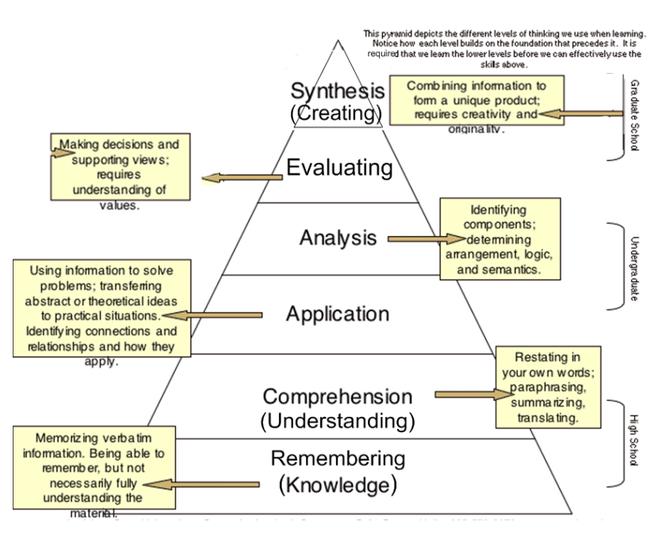

Knowledge
Useful Verbs | Sample Question Stems | Potential activities and products
tell  list  describe  relate  locate  write  find  state  name | What happened after...?  How many...?  Who was it that...?  Can you name the...?  Describe what happened at...?  Who spoke to...?  Can you tell why...?  Find the meaning of...?  What is...?  Which is true or false...? | Make a list of the main events..  Make a timeline of events.  Make a facts chart.  Write a list of any pieces of information you can remember.  List all the .... in the story.  Make a chart showing...  Make an acrostic.  Recite a poem.

Comprehension
Useful Verbs | Sample Question Stems | Potential activities and products
explain  interpret  outline  discuss  distinguish  predict  restate  translate  compare  describe | Can you write in your own words...?  Can you write a brief outline...?  What do you think could of happened next...?  Who do you think...?  What was the main idea...?  Who was the key character...?  Can you distinguish between...?  What differences exist between...?  Can you provide an example of what you mean...?  Can you provide a definition for...? | Cut out or draw pictures to show a particular event.  Illustrate what you think the main idea was.  Make a cartoon strip showing the sequence of events.  Write and perform a play based on the story.  Retell the story in your words.  Paint a picture of some aspect you like.  Write a summary report of an event.  Prepare a flow chart to illustrate the sequence of events.  Make a colouring book.

Application
Useful Verbs | Sample Question Stems | Potential activities and products
solve  show  use  illustrate  construct  complete  examine  classify | Do you know another instance where...?  Could this have happened in...?  Can you group by characteristics such as...?  What factors would you change if...?  Can you apply the method used to some experience of your own...?  What questions would you ask of...?  From the information given, can you develop a set of instructions about...?  Would this information be useful if you had a ...? | Construct a model to demonstrate how it will work.  Make a diorama to illustrate an important event.  Make a scrapbook about the areas of study.  Make a paper-mache map to include relevant information about an event.  Take a collection of photographs to demonstrate a particular point.  Make up a puzzle game suing the ideas from the study area.  Make a clay model of an item in the material.  Design a market strategy for your product using a known strategy as a model.  Dress a doll in national costume.  Paint a mural using the same materials.  Write a textbook about... for others.

\

Analysis
Useful Verbs | Sample Question Stems | Potential activities and products
analyze  distinguish  examine  compare  contrast  investigate  categorize  identify  explain  separate  advertise | Which events could have happened...?  I ... happened, what might the ending have been?  How was this similar to...?  What was the underlying theme of...?  What do you see as other possible outcomes?  Why did ... changes occur?  Can you compare your ... with that presented in...?  Can you explain what must have happened when...?  How is ... similar to ...?  What are some of the problems of...?  Can you distinguish between...?  What were some of the motives behind...?  What was the turning point in the game?  What was the problem with...? | Design a questionnaire to gather information.  Write a commercial to sell a new product.  Conduct an investigation to produce information to support a view.  Make a flow chart to show the critical stages.  Construct a graph to illustrate selected information.  Make a jigsaw puzzle.  Make a family tree showing relationships.  Put on a play about the study area.  Write a biography of the study person.  Prepare a report about the area of study.  Arrange a party. Make all the arrangements and record the steps needed.  Review a work of art in terms of form, colour and texture.

Synthesis
Useful Verbs | Sample Question Stems | Potential activities and products
create  invent  compose  predict  plan  construct  design  imagine  propose  devise  formulate | Can you design a ... to ...?  Why not compose a song about...?  Can you see a possible solution to...?  If you had access to all resources how would you deal with...?  Why don't you devise your own way to deal with...?  What would happen if...?  How many ways can you...?  Can you create new and unusual uses for...?  Can you write a new recipe for a tasty dish?  can you develop a proposal which would... | Invent a machine to do a specific task.  Design a building to house your study.  Create a new product. Give it a name and plan a marketing campaign.  Write about your feelings in relation to...  Write a TV show, play, puppet show, role play, song or pantomime about...?  Design a record, book, or magazine cover for...?  Make up a new language code and write material suing it.  Sell an idea.  Devise a way to...  Compose a rhythm or put new words to a known melody.

Evaluation
Useful Verbs | Sample Question Stems | Potential activities and products
judge  select  choose  decide  justify  debate  verify  argue  recommend  assess  discuss  rate  prioritize  determine | Is there a better solution to...  Judge the value of...  Can you defend your position about...?  Do you think ... is a good or a bad thing?  How would you have handled...?  What changes to ... would you recommend?  Do you believe?  Are you a ... person?  How would you feel if...?  How effective are...?  What do you think about...? | Prepare a list of criteria to judge a ... show. Indicate priority and ratings.  Conduct a debate about an issue of special interest.  Make a booklet about 5 rules you see as important. Convince others.  Form a panel to discuss views, eg "Learning at School."  Write a letter to ... advising on changes needed at...  Write a half yearly report.  Prepare a case to present your view about...

