Visual Arts Supply List

- HB Pencils

- Black Ball-Point Pens (Others are OK, but not as good)

- Black Marker (Sharpie etc.)

- White Vinyl Eraser

- Colour Pencils

- White Blank Hole-Punched Paper, 8.5*11 (Loose-Leaf not Acceptable)

- Duo-Tang

- Ruler

- Small Dollar Store Paint Brushes

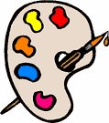

*ALL SUPPLIES ARE TO BE IN CLASS WITH STUDENTS EVERYDAY!*

