- THOUGHTFULLY NOTATE THIS ARTICLE TO SHOW EVIDENCE OF YOUR THINKING THROUGHOUT YOUR READING (text-to-self, text-to-text, text-to-world, and vocab strategies).
- RESPOND TO THE “Food for Thought” SECTION BELOW THE ARTICLE.

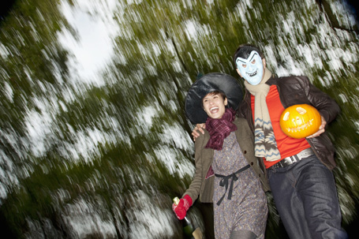

A Ghostly Past: Six Halloween Traditions, Explained

Tim Newcomb http://newsfeed.time.com/2011/10/20/a-ghostly-past-halloween-traditions-explained/ October 20, 2011

Halloween’s Origin
Let’s start with an easy one. Halloween traces back to the ancient Celtic festival known as Samhain. Lore had it that the ancient Gaels believed that on Oct. 31 the worlds of the living and dead overlapped before the start of the new year on Nov. 1. So, with All Souls Day observed on Nov. 1, Oct. 31 became All Hallows Eve, a time where the ghosts of the dead could return to destroy the harvest that was stored leading into winter. As was natural at the time—and led by the Druids—folks burned crops and sacrificed animals on Oct. 31 to ward off the evil spirits before the start of the winter season. How touching.

Trick-or-Treating
There are a few theories here, but the leading thought says that poor children in Britain and Ireland went door-to-door on Hallowmas taking food in trade for the practice of “going-a-souling,” a ritual of praying for the dead on All Saints Day. This practice actually replaced the even older tradition of people leaving food and wine outside for the roaming spirits. While that may be the start of it, that didn’t happen in America, where trick-or-treating may have simply started with children trading songs for treats in the 1910s, according to old newspaper texts. The tradition didn’t really spark until after World War II when popular children’s magazines started discussing it and the idea entered pop culture, including radio shows and cartoons.

Jack-o’-Lanterns
This legend has so many legends within legends that it can be hard to sort them all out. But the basic premise depicts an old Irish farmer, Jack, playing tricks on the devil and then all sorts of completely unrealistic conversations happened between Jack, the devil and God. This resulted in Jack being barred from both heaven and hell and wandering earth as a single flame housed inside carved vegetables. Yeah, believable, huh? Really though, folks believed that carving scary faces onto turnips would frighten away evil spirits. The tradition turned to pumpkins in America because pumpkins were more plentiful, and, let’s face it, far easier to carve.

Costumes
While a small part of the Samhain festival was to either hide from or appease evil spirits, the rise of costumes as a major part of Halloween actually took off in the United States as consumerism of Halloween entered the fray. Initial reports of mass-produced costumes date to as early as the 1930s and really took off to coincide with the rise of trick-or-treating. See, you knew there had to be some serious commercialization behind all this Halloween hoopla.

Witches, Ghosts and the Like
This should be an easy one for us all. All this death and fearing of the spirits gave rise to the skeleton and ghost imagery. But where did the witch fascination come from, other than the fact that witches deal in the evil supernatural? It appears that the European interest in witches was brought to America and joined with the Native American beliefs in evil spirits, which fit nicely with that death and destruction theme on Oct. 31, giving witches and black cats—Druids had convinced people that black cats were humans gone bad—a rise in popular culture.

Haunted Houses
There had to be at least one Halloween item completely devised simply to make money, right? You have it with haunted houses. Playing off the obvious themes of Halloween, the first haunted houses were fundraising efforts led by the Junior Chamber International (Jaycees) clubs and have continued as fundraising and commercial operations.

FOOD FOR THOUGHT:
- Out of the six items above, which one surprised you the most? Why? (Understanding/Analyzing)

- Choose ONE of the sections above, and re-write it so that a six-year-old child could understand it. What questions do you have to ask yourself before you start to write? What choices do you have to make? (Analyzing/Creating)

