Controversy Over Shale Gas Fracking Hits New Brunswick
Posted: 7/15/11 12:33 PM ET http://www.huffingtonpost.ca/hassan-arif

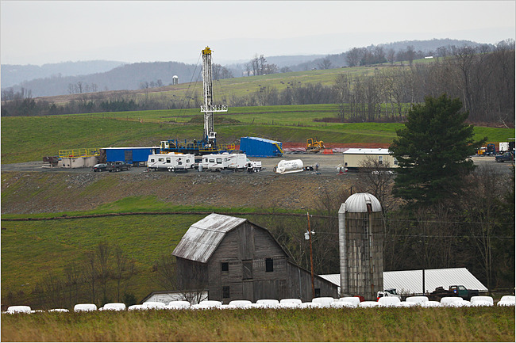

Natural gas has been touted as a "clean source" of energy, however there are serious environmental concerns about the process of extraction known as hydraulic fracturing, or hydro-fracking -- a process that involves pumping a combination of sand, water, and chemicals into the ground, creating cracks in shale rock, whereby natural gas can be extracted.
One concern is that the chemicals involved in the process can potentially contaminate nearby water supplies. There is also the issue of transporting these chemicals, with concerns about the consequences of an accident. In addition, there is the initial flaring of natural gas into the atmosphere. Furthermore, there are questions about proper disposal and storage of the wastewater created by this process.
There is serious debate over the ecological viability of hydro-fracking throughout North America, with concerns that any economic gains from the process are outweighed by the detrimental environmental consequences.
In New York state, there is controversy over the governor's decision to allow the practice. In New Jersey, the Senate passed legislation banning hydro-fracking altogether. In Canada, Quebec has placed a moratorium on further hydro-fracking until more stringent regulations are in place.
The most recent front in the controversy over this issue is New Brunswick, where the Progressive Conservative Premier David Alward hasrefused to ban the establishment of fracking operations in the province.
Economic development is important, but it cannot come at the expense of the environment. New Brunswick's natural vistas are a source of local pride, and overall environment -- including air and water quality -- are important contributing elements to quality of life. In a so-called "have not" province like New Brunswick, governments have often felt they had to prioritize economic development over environmental concerns -- however the consequences of such thinking can be overall detrimental.
In the mountainous Appalachian state of West Virginia, as well as in neighbouring mountainous regions of Kentucky and Tennessee, there is a process of mining for coal called mountaintop removal. This involves literally blasting mountaintops off as a cheaper and less labour-intensive alternative to mining for coal.
This practice has destroyed the landscape of the region, creating bleak moonscapes where scenic forested mountains once stood. Potential economic opportunities in eco-tourism have been destroyed, and also an important part of the region's identity.
Mountaintop removal creates airborne pollution as well as pollution of nearby waterways. Furthermore, slurry ponds are created to store the waste from this process; and breach of these slurry ponds -- which has happened -- has disastrous ecological consequences.
This example shows the consequences of profit trumping environmental conservation, and while hydro-fracking is a very different process than mountaintop removal, it highlights some of the concerns that have to be taken in New Brunswick in balancing environmental concerns with economic ones. The provincial government cannot think solely in dollar terms; it must account for quality of life factors, including the surrounding environment.
New Brunswick's official opposition Liberals have called for a moratorium on hydro-fracking until stricter regulations and government oversight (i.e. proper staff to oversee enforcement of regulations) are in place. They have raised concerns about potential damage to property, to the water supply, and to the environment.
"When it comes to developing our natural resources -- first, we must do no harm to our environment," New Brunswick Liberal leader Victor Boudreau stated, expressing an important sentiment regarding this issue. Where the Alward government has often seemed hesitant to take a firm stand on contentious issues, this firm stand by the Liberals is a favourable contrast.
It is important to consider the overall desirability and sustainability of hydro-fracking as well. A 60 Minutes story on fracking highlighted the uncertainty over whether problems with hydro-fracking are due solely to human error and corporate negligence, or if the practice overall carries serious risks such as contamination of nearby water supplies.
Would regulations and government oversight be enough? Should the practice be banned altogether?
These questions should be on the table in properly assessing the viability of hydro-fracking.
A year ago, Green Party leader Elizabeth May strongly condemned the exploration of shale gas -- which was then being considered in Quebec -- stating it was undesirable to "chase after these unsustainable forms of fossil fuel" and that instead, investment should be made in green sources of energy.
Ms. May raised concerns about the lack of scientific understanding of this issue, the large amount of water used, and overall concerns about contamination, stating "there are so many problems with this technology it really is not worth pursuing."
The New Brunswick Liberals' position is a positive start and hopefully marks a move towards greater emphasis on sustainable development and creating a provincial economy that is in harmony with the natural environment; something that would involve emphasis on green energy sectors and eco-tourism, among other things.
New Brunswickers need to protect their province and preserve it as a desirable and sustainable place to live. It is important to not allow economic calculus to trump environmental sustainability, which involves properly weighing whatever economic benefits there are of hydro-fracking with any serious environmental detriments -- and to consider if the practice is environmentally sustainable at all.
FOOD FOR THOUGHT:
In news items, writers are supposed to refrain from BIAS, and make their writing as objective as possible. This does not seem to be the case in this article.
- Explain the writer’s bias evident in this article. (Understanding)

- Now, take the point of view of Premier David Alward. List five of the high points you would use in selling the idea of hydro-fracking to the people of New Brunswick. (Analyzing)

- How about YOU? Now that you’re a little more informed, what are YOUR views on hydro-fracking? (Evaluation)

