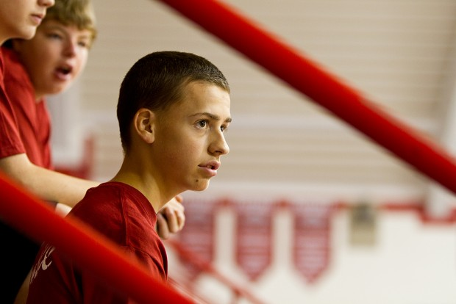
Ontario class hits gym in search of brain boost

Niagara region hopes exercise regime will help improve its students’ marks

John Rieti CBC News

Posted: Sep 17, 2011 2:58 PM ET
Grade 10 students at Eastdale high school in Welland, Ont., are one of the two pilot classes trying out Sparking Life Niagara. For 20 minutes every morning they will exercise at close to their maximum heart rate in an effort to boost their learning power. (John Rieti/CBC)
Teacher Tracy Garratt, who specializes in drama and English, is in charge of the class of ten boys. Here, Garratt outfits her class with heart rate monitors. (John Rieti/CBC)
The program calls specifically for cardiovascular exercise. The boys must exercise at 65-75 per cent of their maximum heart rate for a sustained 20 minutes for optimal results. (John Rieti/CBC)
The students were specially chosen at the end of last school year. Most of the class, shown here having a water break before working out, is underperforming academically. (John Rieti/CBC)
Though Eastdale has a bustling sports program, the class works out in a separate area above the gym and the exercise isn’t linked to any competitive sport. (John Rieti/CBC)
The boys can choose from exercise bikes, treadmills, or elliptical machines for their workout. The equipment was donated by community businesses. (John Rieti/CBC)
“It gets you pumped up for the rest of the day … if you're tired and you do this, you're actually not that tired for the rest of the day," Cody Paquin, 16, says. (John Rieti/CBC)
Sparking Life Niagara is based on the idea that exercise is like ‘miracle grow’ for young brains. The program has been successful in individual schools in the U.S. and Canada. (John Rieti/CBC)
Robbie Dilts, 15, was one of few boys to push hard during the first week of workouts. Dilts says: “It's been great so far and it's going to be great to do this every day.” (John Rieti/CBC)
Several of the students said the program is different from what they’re used to, but they’re willing to give it a try. (John Rieti/CBC)
Teacher Tracy Garratt says: “I really feel that all students can benefit from this. My hope and my dream is that every kid in my school and every kid in my district actually gets some activity in the morning.” (John Rieti/CBC)
The boys’ physical progress is monitored by the school nurse. 15-year-old Cory Avery, pictured here, says “I thought it wasn't for me, but I gave it a shot and I like working out … and if it has a chance of making me smarter it's worth a shot.” (John Rieti/CBC)
The real challenges – attendance, behavior and learning – will all take place in the classroom. Here, the students practice reading comprehension and spelling. (John Rieti/CBC)
The boys’ academic improvements will be evaluated at the end of term in February. (John Rieti/CBC)
If the Sparking Life Niagara pilot project is a success, it could be a part of student life for hundreds of youth across the Niagara region. (John Rieti/CBC)

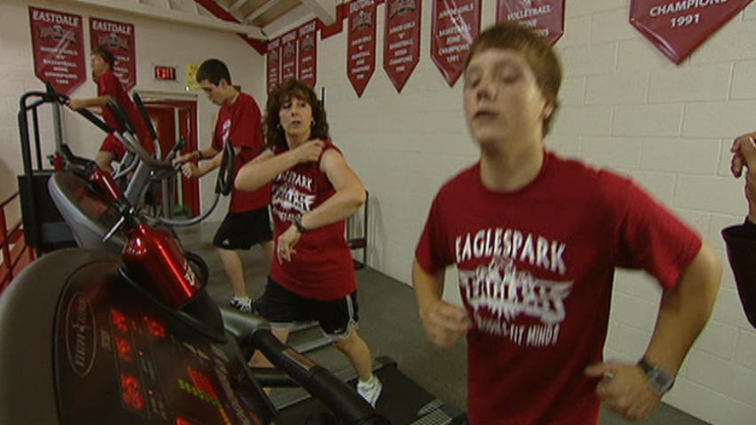

Beginning of Story Content
Ten high school boys push themselves through 20 minutes of exercise on treadmills and exercise bikes. Some work up a sweat, while others lounge and crack jokes on the equipment.
Their teacher, Tracy Garratt, doesn’t mind too much. She’s already looking forward to getting them into the classroom.
“Once they've had some physical activity in them, at least for the first 20 minutes they're mine,” Garratt says, with a smile.
It’s the third day of school and the third workout for the class, one of two groups taking part in Sparking Life Niagara — a pilot project that aims to boost the students’ learning ability by having them get 20 minutes of intense cardiovascular exercise each morning. About 20 Grade 10 students were selected to take part in the program, but so far only ten — all boys — have shown up.
Garratt says she’s already seeing improvements in the students who have attended the classes.
Teacher Tracy Garratt, left, said she's confident the Sparking Life Niagara students will help her students succeed academically. (John Rieti/CBC)
“I really feel that all students can benefit from this. My hope and my dream is that every kid in my school and every kid in my district actually gets some activity in the morning,” she says.
Programs similar to Sparking Life Niagara have already proven successful in some U.S. and Canadian schools, but there’s keen interest whether it will work at Eastdale. The school is in an area hit hard by the economic recession, and residents have higher-than-average obesity rates and other health issues.
The boys are curious whether it will work, too.
“I think that there is a chance,” says 15-year-old Cory Avery. “I’m going to take it because I want to be better in my learning.”
Eastdale picked students who were underachieving academically, but who teachers thought would make academic gains in the program. But while students like Avery recognize the potential opportunity of the class, others are already threatening to drop out.
“Many kids felt like they were being … put out there,” Avery said.
“Maybe they feel like they’re being labeled, and not many kids want that.”
The biggest question at this point in the school year is whether the boys will buy in and really test out the program.
Question:
Based on what you know about Sparkling Life Niagara and reports from similar programs, how successful do you believe a program like Sparkling Life Niagara would be at JMH? Support your answer.

