1. THOUGHTFULLY NOTATE THIS RECIPE TO SHOW EVIDENCE OF YOUR THINKING THROUGHOUT YOUR READING (text-to-self, text-to-text, text-to-world, and vocab strategies).
2. RESPOND TO THE “Food for Thought” SECTION BELOW THE ARTICLE.
_____________________________________________________________________________________
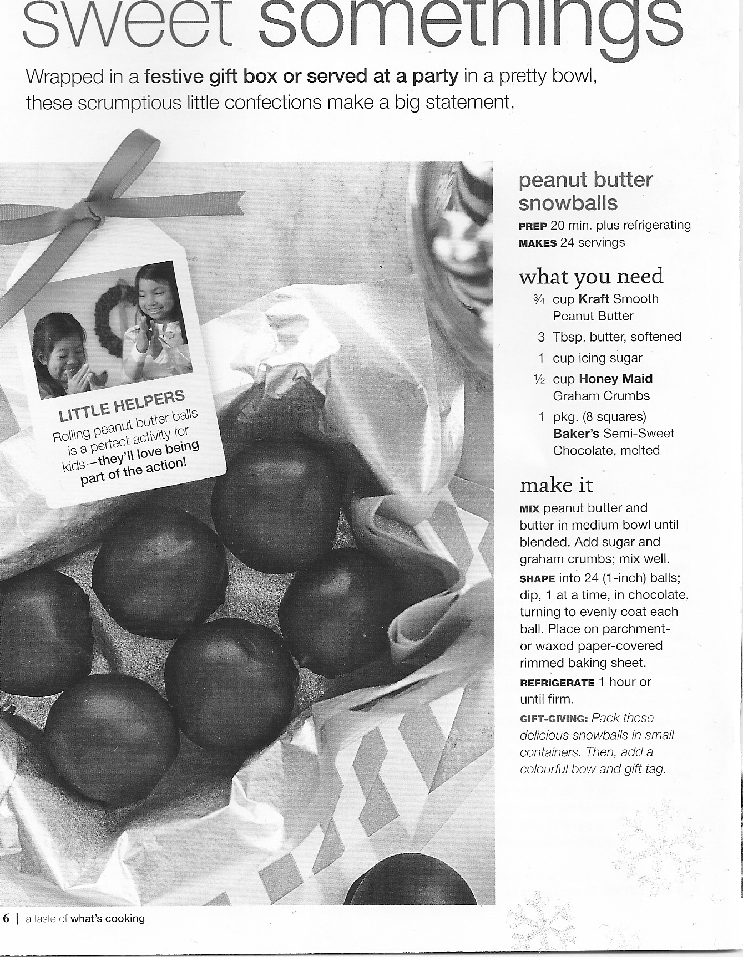
- The description lines under the main title refer to “ scrumptious little confections.” In the context of this sentence, what does this expression probably mean (Applying)?

- From the beginning of the first task, until the treats are ready to eat, how long will the process take (Remembering)?

- A) In the category “ What you need,” the ingredients call for Kraft Smooth Peanut Butter, Honey Maid Graham Crumbs, and Baker’s Semi-Sweet Chocolate. Why are these in bold (Analyzing)?

B) If you had Skippy Smooth Peanut Butter or No Name Smooth Peanut Butter instead, how would that affect the recipe?

- What is the point of the “Little Helpers” tag insert (Applying)?

- Is this page more advertisement, or more recipe? List evidence to back up your choice (Evaluating).

