ESD

Read the information on the website below and answer the following questions:

http://www.pccomputernotes.com/esd/esd.htm

- Define and Describe ESD (5)

- How can the potential for ESD be decreased? (3)

- When is ESD risk at its greatest? (2)

- Explain the 2 types of failures that can occur with ESD (4)

- Explain how Antistatic Wrist Straps Work? (2)

- What are ideal conditions to work on a computer? (2)

- How do Anti-Static bags work? (1)

- What is the best flooring to have in a computer workshop? (1)
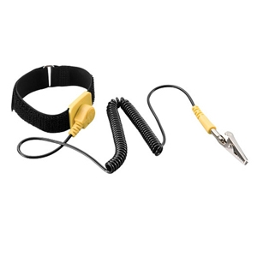

Tools
Label the toolkit below

http://www.rosewill.com/products/558/ProductDetail_Specifications.htm

