Tech Support
Exam Review

Computer Safety

Define and explain ESD.

Name 2 ways that you can protect your self from ESD

What is the best flooring to have in your computer workshop? Why?

Hardware

What is the difference between a hard drive and a floppy drive?

What component is known as the brain of the computer? Why?

Why is it important to document the disassembly/reassembly process of the computer?

If you were going to update one component in your home computer what component would you choose? Why?

Internet

What are domain names?
Explain the difference between .com .ca .gov .edu
What is an ISP?
Name two ISP’s in our area.
What was the Dot-Com bubble? Why did it burst? What was the aftermath?

Web 2.0

Define and describe the following terms

Blogging (Blogger, Wordpress)
Microblogging (Twitter)
Youtube
Social Bookmarking (Delicious)
Social Networking (Facebook)
RSS
Digital Footprint

Label the 10 lines in the diagram below and list what you can plug into the port.

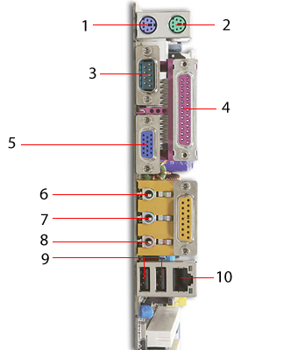
1.
2.
3.
4.
5.
6.
7.
8.
9.
10.

Motherboard Labeling

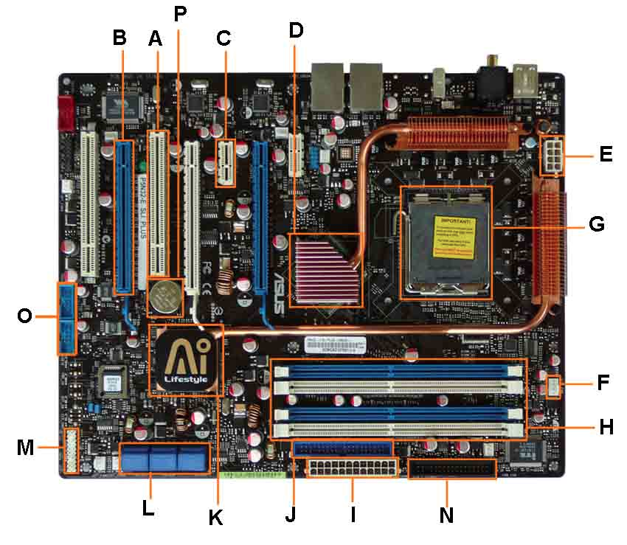

Using the letters below, label and explain each component on the motherboard.

A.
B.
G.
H.
I.
P.

Operating System/Hardware

Why do you have to format a hard drive?

Why do users partition hard drives?

If you were to upgrade any 2 pieces of hardware on your computer which would you choose and why? Describe function of each

You just finished installing an operating system on a client’s computer. After rebooting the computer you notice that you have no sound.

Give a detailed set of step-by-step instructions that describe the process of fixing this problem.

Networking

Why would you want to share a folder on a network?

Why would you set up permissions on folder?

What is the difference between DHCP and a Static IP address?

What is remote desktop? Describe 2 uses for remote desktop.

Fill in the blanks for each of the 4 numbers below. For each of the numbers that you fill in, explain in detail that the role that each component plays on the network.
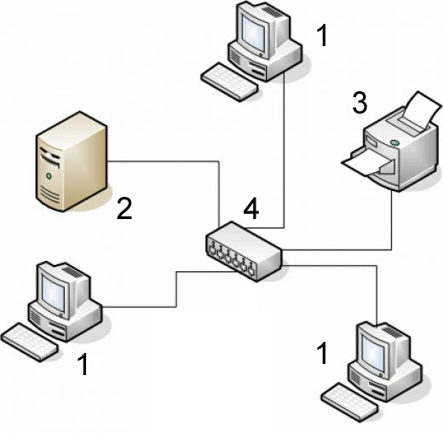

1.

2.

3.

4.

What is a firewall? What are the 2 types of Firewalls?

Define and describe a LAN and a WAN and how are they different from each other?

Name 3 things you can do to add security to a network?

