Kony 2012 just empty clicks, writes Andrew Bolt
by: Andrew Bolt From: Herald Sun March 12, 2012 12:00AM
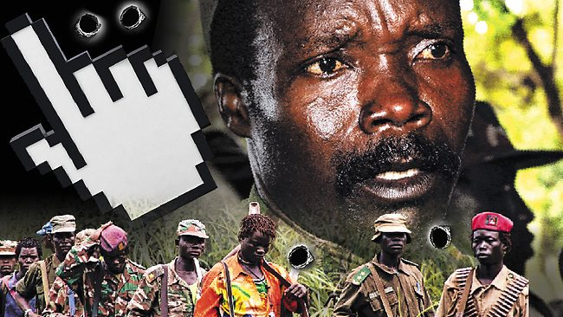
Kony 2012 is the ultimate symbol of no-sweat moralising. Picture: Source: Herald Sun

IN some jungle in Africa, a mass-murderer called Kony is shattered. A few million people on Facebook have unfriended him.
And millions who'd never heard of Joseph Kony can relax, having advertised their goodness by clicking the share button on YouTube.
Wow, and I thought the LiveEarth concerts - bopping to top bands while screaming at governments to save the planet - couldn't be topped.
But here's the ultimate symbol of our new no-sweat moralising: the Kony 2012 video that's been watched by 60 million people in just one week.
This slick 30-minute film by the Invisible Children advocacy group tells what a monster Kony is, and what should kind-of be done about him.
And, yes, the leader of the semi-mystical Lord's Resistance Army is vermin, having had his rebel "army" kidnap up to 30,000 children as soldiers and prostitutes, and kill and mutilate countless civilians in Uganda's Gulu area and beyond.
But how is this film - by Invisible Children co-founder Jason Russell - to stop him?
Well, explains Russell, last October, the US sent 100 American advisers to help Uganda's army to catch Kony.
"But if the government doesn't believe the people care about arresting Kony, the mission will be cancelled. In order for the people to care, they have to know. And they will only know if Kony's name is everywhere."
And Facebookers can do it.
"The better world we want is coming. It's just waiting for us to stop at nothing ... Above all, share this movie online."
How intoxicating for virtual friends everywhere. One click and Kony's gone. The world remade. And they don't even have to leave the house.
How intoxicating for virtual friends everywhere. One click and Kony's gone. The world remade. And they don't even have to leave the house.
But there's some basic problems with Invisible Children's pitch - as in, Kony isn't where you'd think, or the threat you'd think.
Contrary to the impression the movie gives, Kony was chased out of Uganda six years ago - probably to the Central African Republic, and is down to a few hundred fighters.
Most of the 30,000 children actually taken over nearly 30 years - are no longer with him.
"There has not been a single soul from the LRA here since 2006," Dr Beatrice Mpora, director of Gulu's Kairos health organisation said.
"Now we have peace, people are back in their homes."
And as for the 100 US advisers sent last year, who says they were about to be pulled out?
So what is this film really about?
In fact, its soundtrack includes the warning squeaks of an ego being stroked.
The film shows at length Russell's adorable young son Gavin being told how daddy has devoted years to getting Kony caught, ever since he made a promise.
We then see that promise being made theatrically to a sobbing Ugandan boy whose brother Kony killed.
Russell: "We are also going to do everything that we can to stop them. Do you hear my words?"
Boy: "Yes."
Russell: "You know what I mean?"
Boy: "Yes. Yes."
Russell: "We are, we're going to stop them." (Music swells.) "We're going to stop them."
And the film ends with Gavin deciding daddy is a hero: "I'm going to be like you, Dad."
Oh, and you can help Russell's work, the film adds, by buying a bracelet with a "unique ID" to show you care.
What practical good your donation will do is not clear, since $10 million of Invisible Children's income last year went on its staff, surplus and their awareness raising, and just $3 million on Central African projects.
Don't mistake me. I do want help for Africa's children, and donate myself. But in Rwanda, bare weeks after the genocide, I saw what real charity looked like.
I met a Lithuanian priest, Father Hermann Schulz, half mad with grief and fury, after his Salesian orphanage was destroyed by the men who came to kill his children, and as we searched refugee camps for survivors, Schulz swore he'd rebuild.
And when I met him again years later, by God, he'd done it. Years of his life, it had taken. Sweat.
That, and the donations of those who helped Schulz, represent real good.
It's not "raising awareness" but giving help. Not about buying a wristband to advertise goodness, but giving money to achieve it.
But seeming good today often trumps doing it.
We have a showy new green faith with not a single hospital, school nor nursing home run in its name.
We have millions switching off lights for one hour, thinking they're saving the planet.
We have 250,000 people walk over a bridge, thinking they've helped Aborigines.
And we now have Facebookers unfriending Kony, thinking they've put a killer in his box.
FOOD FOR THOUGHT:
YOU’LL HAVE TO ANSWER THESE ON A SEPARATE SHEET OF PAPER, AND ATTACH THEM TO YOUR ARTICLE.
- How is the TONE of this Article of the Week a little different from those we have read so far? Why do you think that is? (Analyzing)

- (a) Using evidence from this article, explain two of the potentially questionable aspects of the Invisible Child group. (Understanding)
(b) Explain how the author uses his own experiences to downplay the efforts of Invisible Child. (Analyzing)
(c) After reading this Article of the Week, have your views on the KONY 2012 campaign changed? Explain clearly, please. (Evaluating)

