Motherboard Labeling

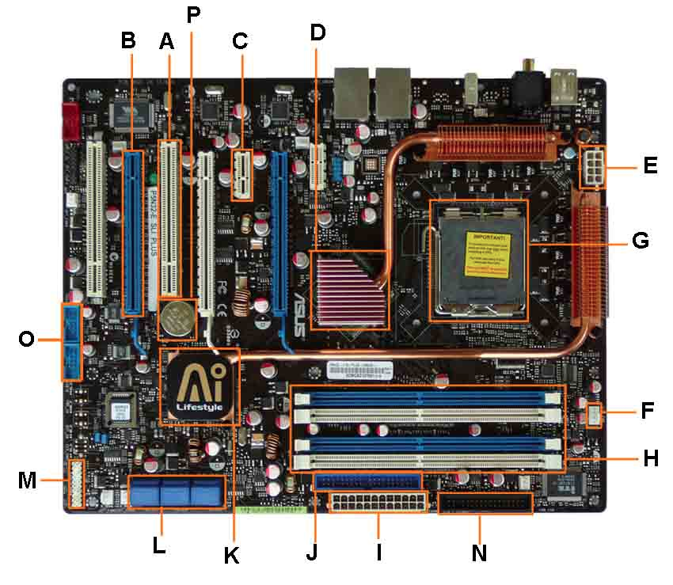

Using the letters below, label and explain each component on the motherboard.

A.
B.
E.
F.
G.
H.
I.
J.
O.
P.

Value 20

