Tech Support
Quiz 1

1. Write a ½ page single space essay about one person in the list below. Write your piece in Arial 12pt font.

Choose a person from the list below:

- Charles Babbage
- Steve Wozniak
- Stephen Jobs
- Bill Gates
- Alan Cooper

Include the following information in your response

- What company did they work for?

- What impact did they have on the computer industry?

- What are their greatest accomplishments?

Value 10

2. ESD

- Define and explain ESD. Value 2

- Name 2 ways that you can protect your self from ESD Value 2

- What is the best flooring to have in your computer workshop? Why? Value 2

3. Label the 10 lines in the diagram below and list what you can plug into the port.

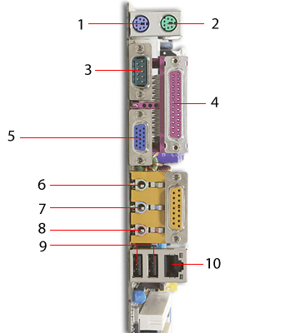
1
2
3
4
5
6
7
8
9
10
Value 10
4. Label the ports in the diagram below and describe what you would plug in to the port. Value 8

A.
B.
D.
G.
I.
J.
K.
L.

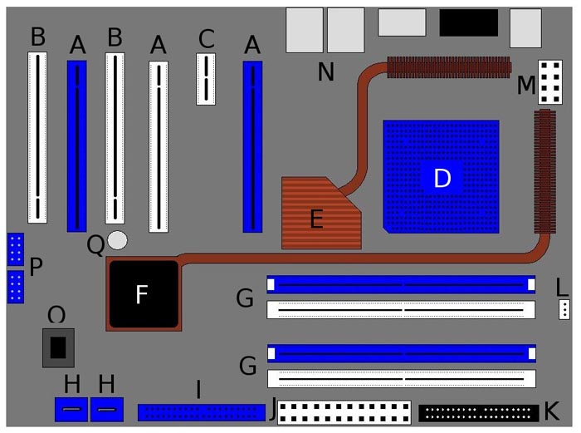

- What is the difference between a hard drive and a floppy drive? Value 2

- What component is known as the brain of the computer? Why? Value 2

- Why is it important to document the disassembly/reassembly process of the computer? Value 1

- If you were going to update one component in your home computer what component would you choose? Why? Value 2

