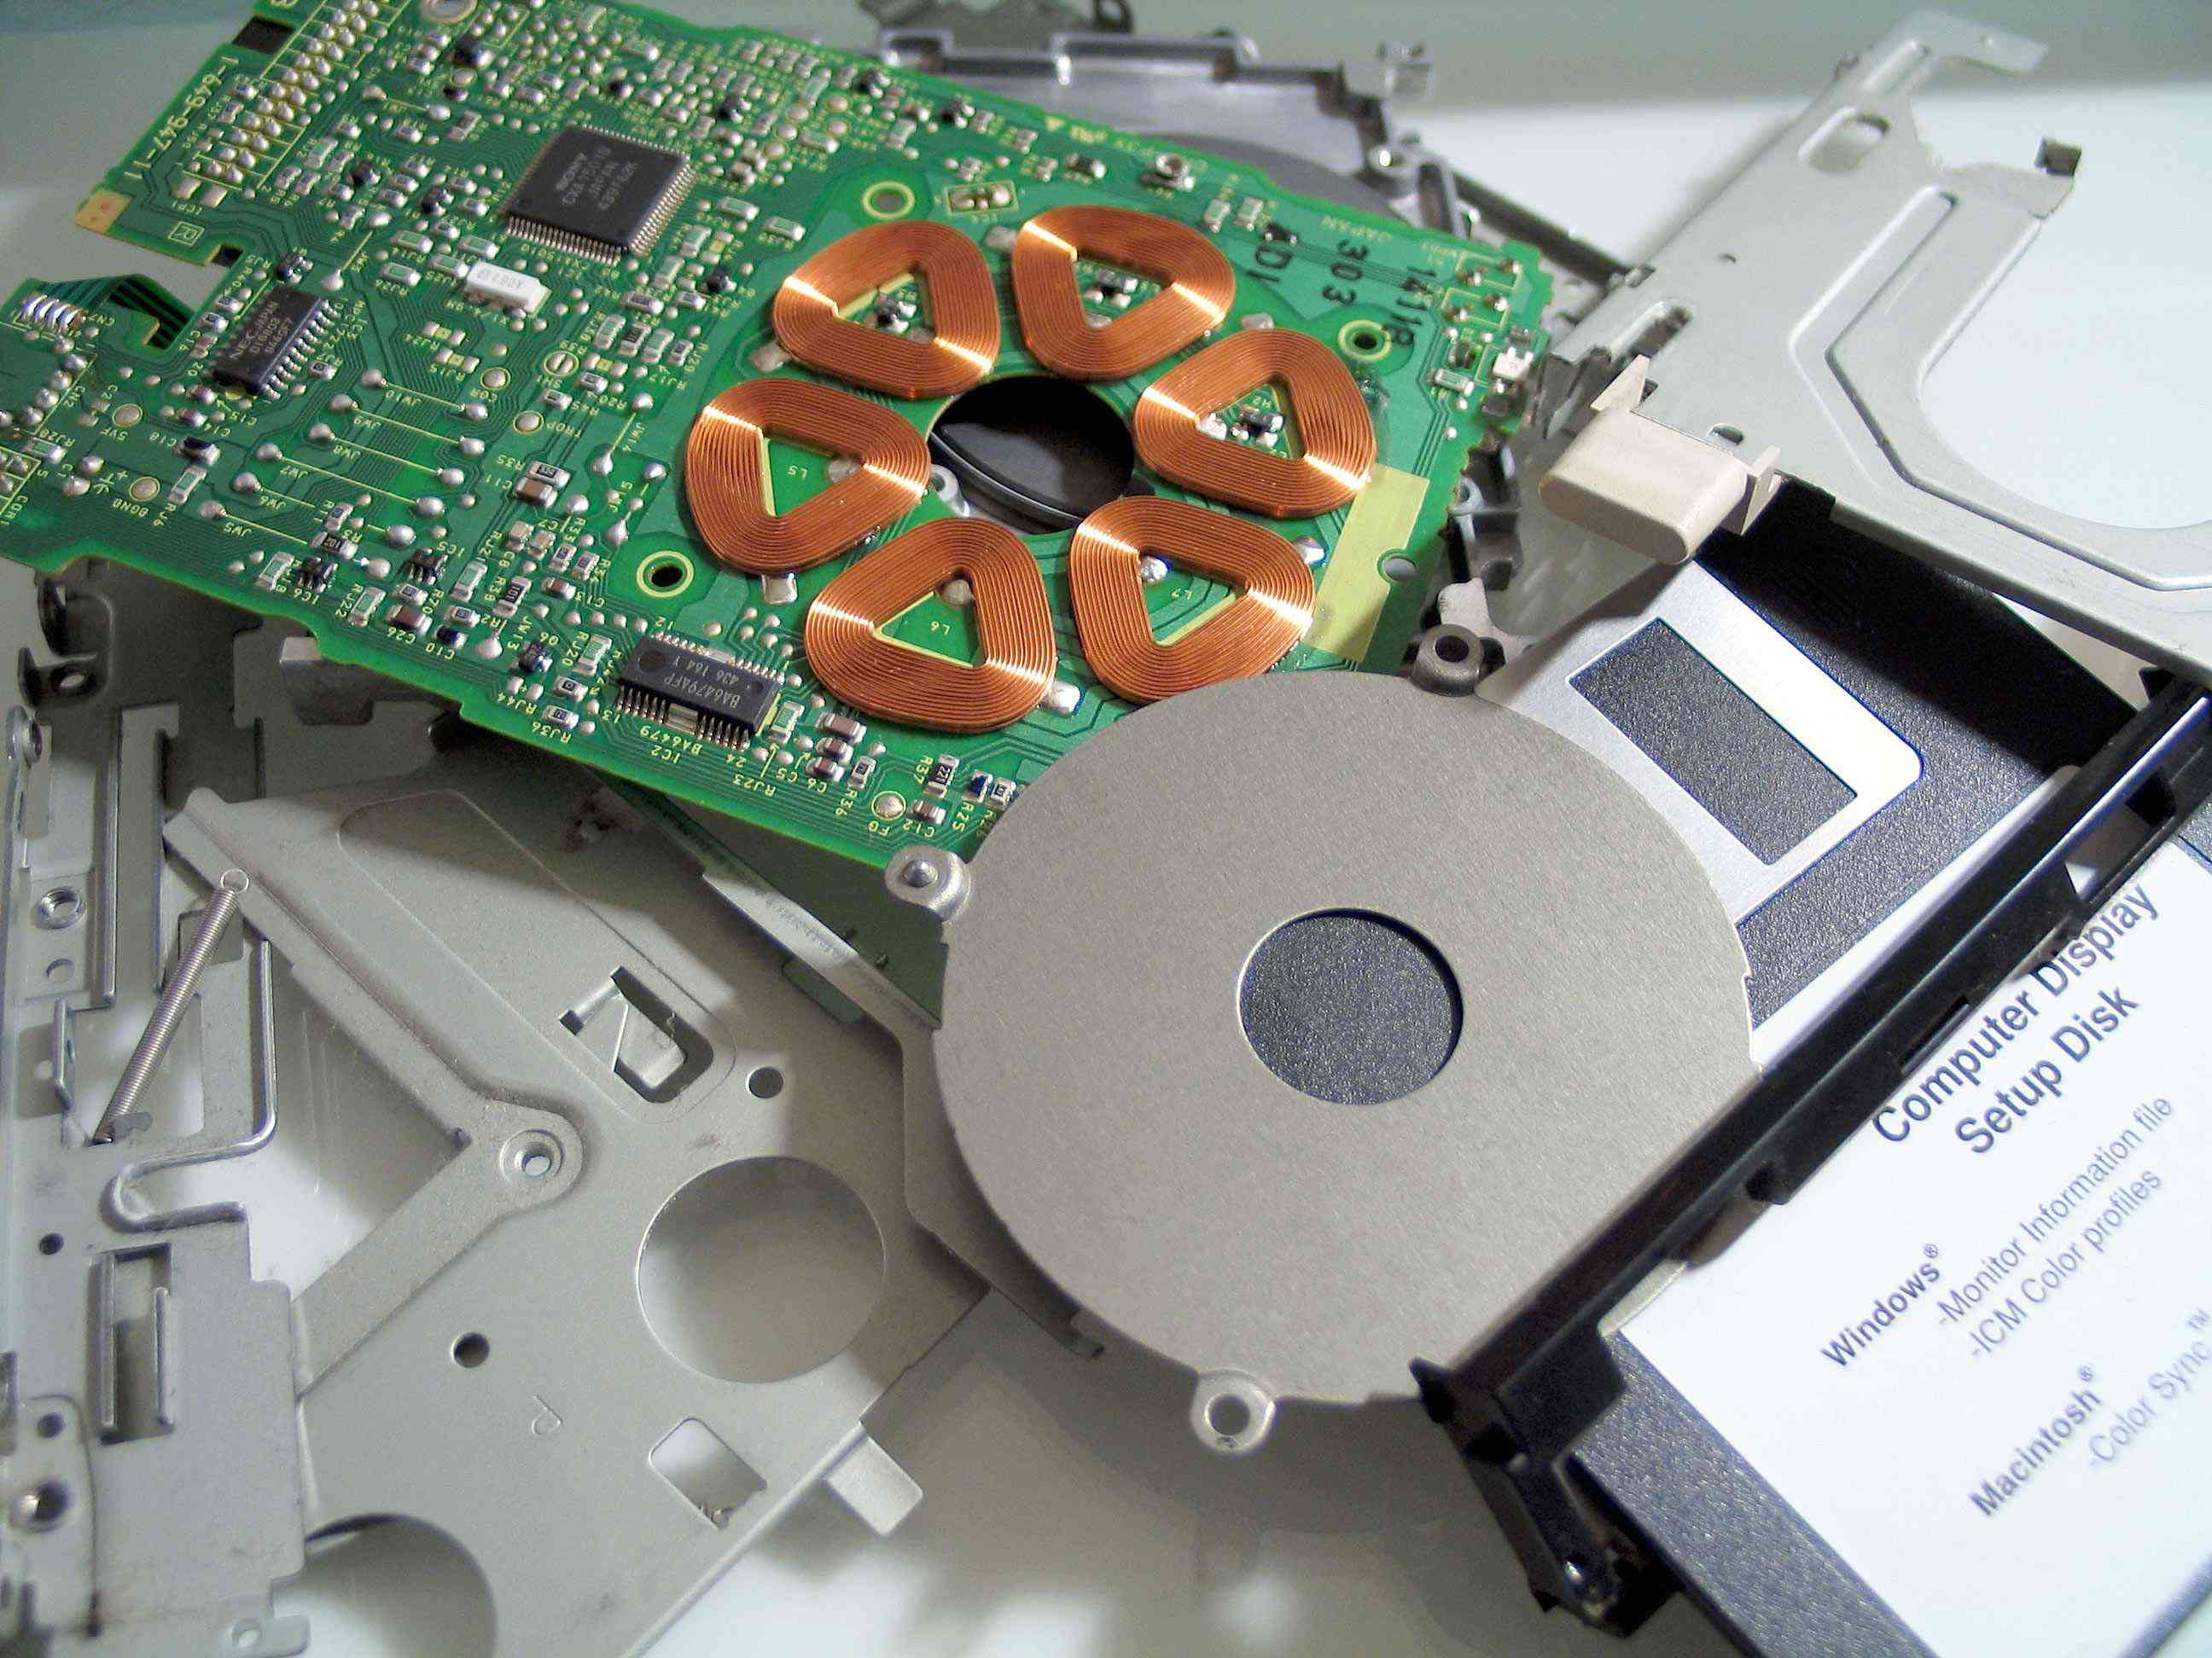
Tech Support Case Study

You received a call from a customer that their computer is working very poorly. It is very slow and is working much worse than when they bought it. They are reporting numerous tool bars in their browser and are receiving unwanted pop-ups. They are also reporting that the Anti-Virus on their computer has been expired since 2009. You ask the customer to drop off the computer at your workshop.

The customer leaves you 1 CD that originally came with the computer when they purchased it. It is Windows XP professional.

After opening the case you discover that the insides are very dusty and you gather the following information:

The system has a Gigabyte GA-965P-DS3 Motherboard
2 open ram slots (512 Megabytes Installed)
1 40 Gig SATA (Serial ATA) hard drive
PCI Express ATI X300SE 64MB Video Card

After running an updated virus and spyware scan on the computer you discover that the computer is infested with malicious files and decide that your only option is to do a reformat.

You call the customer and inform them of your decision. You tell them they some of their hardware components are out of date and so is their operating system. They decide that they are willing to spend 500 dollars on hardware (new ram, hard drive and video card) but do not want to spend any money on a new operating system. You discuss the Windows XP Professional CD that they left with you and you both decide that you will do a reinstall of the current operating system (Windows XP Professional).

Question 1

A. Using the Internet, navigate to a website that sells computer hardware components. Research 2 different options for each hardware component for your customer. Insert the information that you find in the tables below.

Research the brand of motherboard that this computer has to ensure compatibility of your hardware.

Possible sites for hardware sales

http://www.newegg.ca
http://www.tigerdirect.ca

Brand & Model Number | Features of Hardware | Cost of Component
Ram
Hard drive
Brand & Model Number | Features of Hardware | Cost of Component
Brand & Model Number | Features of Hardware | Cost of Component
Video Card
Brand & Model Number | Features of Hardware | Cost of Component

B. Based on your research which 3 components (1 of each) will you recommend to your customer? Value 3

C. What factors did you use for making these decisions? Value 2

D. What was the total cost of your components? (Show your work)
(Value 2)

Question Value 25

Question 2

After successfully installing all of the new hardware components you install the operating system.

After rebooting the computer you notice that you have no sound. You immediately go into Device Manager to assess the situation. You notice that under Other Devices there is a yellow question mark beside Multimedia Audio Controller.

Give a detailed set of step-by-step instructions that describe the process of fixing this problem. Value 15

Include the url to where you found your drivers.

Question 3

What is Purpose of the System Configuration Utility? (MSCONFIG)

List and explain the purpose of each of the tabs located along the top of the window (General, SYSTEM.INI, WIN.INI, BOOT.INI, Services, Startup)
(Value 10)

What is the purpose of the registry? (Value 2)

What is the purpose of a driver? (Value 3)

Total Value 50

