Quiz 2
Tech Support
Mr. O’Toole

OS/Hardware

- Why do you have to format a hard drive? (1)

- Why do users partition hard drives? (1)

- If you were to upgrade any 2 pieces of hardware on your computer which would you choose and why? Describe function of each (1)

- You just finished installing an operating system on a client’s computer. After rebooting the computer you notice that you have no sound.

Give a detailed set of step-by-step instructions that describe the process of fixing this problem. (5)

Networking

- Why would you want to share a folder on a network? (1)

- Why would you set up permissions on folder? (1)

- What is the difference between DHCP and a Static IP address? (2)

- What is remote desktop? Describe 2 uses for remote desktop. (2)

- Fill in the blanks for each of the 4 numbers below. For each of the numbers that you fill in, explain in detail that the role that each component plays on the network. (8)
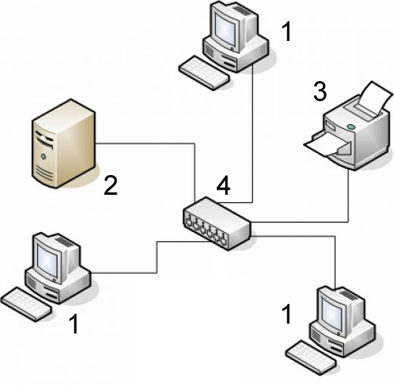

1.

2.

3.

4.

Security

- What is a firewall? What are the 2 types of Firewalls? (2)

- Define and describe a LAN and a WAN and how are they different from each other? (3)

- What are 3 things you can do to add security to a network? (3)

Value 30

