Skydiver breaks sound barrier

'The most exciting moment was when I was standing at the door above the world'

CBC News Posted: Oct 14, 2012 6:39 AM ET Last Updated: Oct 14, 2012 5:59 PM ET

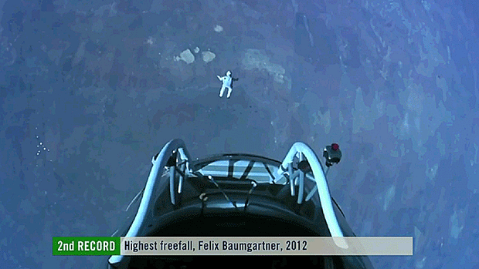
Felix Baumgartner of Austria leaps into a record-setting free fall. (Red Bull Stratos/YouTube)
Extreme athlete Felix Baumgartner made a death-defying free fall that made him the first skydiver to break the sound barrier, according to organizers.
In a journey that lasted 4 minutes and 20 seconds, he fell at a speed of 1,342.8 km/h, which broke the sound barrier — 1,200 km/h. That amounts to Mach 1.24, which is faster than the speed of sound. No one has ever reached that speed wearing only a high-tech suit.
He has broken the record for the highest free fall ever, the fastest free fall and the highest manned balloon ride, said organizers.
"Sometimes we have to get really high to see how small we are," Baumgartner told reporters shortly after the jump.
"The most exciting moment was when I was standing at the door above the world."
The Austrian man's feat also marked the 65th anniversary of U.S. test pilot Chuck Yeager's successful attempt to become the first man to officially break the sound barrier aboard an airplane.
Baumgartner took off from a launch site in Roswell, N.M., on Sunday in a pressurized capsule carried by a 55-storey ultra-thin helium balloon and took nearly three hours to climb into the stratosphere.
"On the step I felt that the whole world's watching. I said I wish they would see what I see. It was amazing," said Baumgartner.
The jump from the edge of space was postponed on Monday and Tuesday because of unexpected winds, but the weather was deemed calm enough for his latest attempt.
Mission control was silent for the first minute as Baumgartner spun around on his way down. Before the two-minute mark, he stabilized and the crew on ground broke into cheers and whistles.
Baumgartner, 43, had been training for five years for the jump, during which he was expected to be in a free fall for some five minutes before opening a parachute at 5,000 feet above ground. However, he opened his chute around the 4:18 mark.
He spoke to mission control throughout his fall and glided safely to the ground — coming up on his knees and pumping his fists in the air. His family, at mission control, leapt to their feet and clapped in relief.
The current record for a high-altitude skydive was set in 1960 by Joe Kittinger, who jumped from a balloon flying at 31,333 metres, Kittinger, a retired U.S. Air Force colonel, fell for four minutes and 36 seconds and reached a maximum speed of 988 km/h before opening his parachute.
The Austrian athlete hoped to top that by exceeding 1,110 km/h — the speed of sound at the targeted altitude — and freefalling for five minutes and 35 seconds, from 123,000 feet above sea level.
The jump was more than three times the height of the average cruising altitude for jetliners.
Just short of the halfway point to the stratosphere, the temperature outside the capsule was -62 C.
To keep Baumagartner safe, a special suit was designed, similar to an astronaut's and meant to withstand extreme conditions. Canadian space suit engineer Shane Jacobs spent the last three years building the pressurized suit.
Jacobs says one of the most dangerous things that skydivers at high altitudes face is going into a flat spin, in which the body rotates horizontally.
"This could create g-forces that can make you unconscious," he told CBC News.
"When he's jumping from such high altitude, even though he's a very experienced skydiver and he knows how to position his body when he normally skydives from low altitudes, the atmosphere is so thin, that there isn't enough atmospheric drag to really push against to control your body."
When Kittinger jumped 52 years ago, he used a drogue parachute, in addition to the main chute, to gain stability. A drogue chute is a high-speed parachute which has smaller surface area than a conventional parachute.
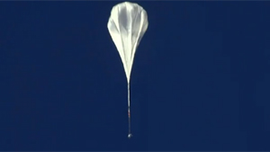
The balloon at 60,000 feet (18,300 metres), more than one hour into the ascent
"For this mission we didn't want to nominally deploy a drogue chute because we want Felix to be able to hopefully break the speed of sound."
There were safety processes in place to ensure Baumgartner's safe return to earth.
"We have a system [which he wore on] his wrist that measures g-forces, and if they build up for a great amount of time it automatically deploys the drogue chute, which will stabilize him," Jacobs said.
Dr. Jonathan Clark, Baumgartner's medical director, had said the pressurized spacesuit will protect him from the shock waves of breaking the sound barrier.
Jacobs said a nearly invisible wire had been embedded inside Baumgartner's visor to prevent it from fogging. The suit is airtight, but "breathable to water vapor to reduce his thermal burden and allow him to maintain his comfort whether he is in extreme cold or extreme heat."
"The world needs a hero and today they got one," said Clark.
When asked what his next venture would be, Baumgarner responded with an a nod to Kittinger.
"Honestly, I want to inspire the next generation. I would love to be here in four years and there a young guy sitting next to me because he wants to break my record," he said.
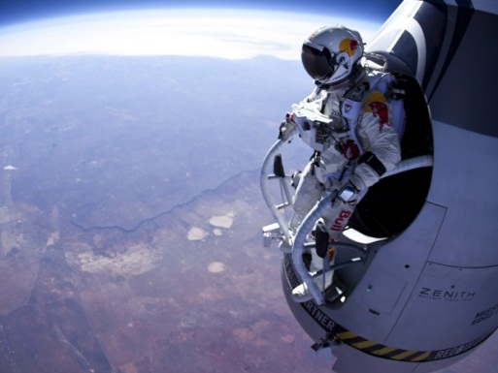
- Extreme athelete and skydiver Felix Baumgartner prepares to jump during his first test flight over Roswell, N.M. on March 15, 2012. Baumgartner is on a mission to the edge of space to an altitude of 37,000 metres to break several records including the speed of sound in freefall during his jump. (Jay Nemeth/Red Bull/AP)
FOOD FOR THOUGHT: Looking for your evaluation here…is this something worth celebrating? Why or why not?

