‘Bright Young Things’: Victoria’s Secret’s Line Under Fire
By Bonnie Rochman March 29, 2013 http://healthland.time.com/2013/03/29/bright-young-things-victorias-secrets-line-under-fire/?iid=hl-article-mostpop1

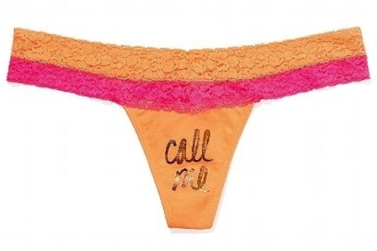
Sex sells, but are suggestive marketing campaigns right for tweens and teens?
Diana Cherry’s daughters are ages two, five and six, way too young to consider flaunting lacy thongs that beckon “Call Me” on the crotch.
But Cherry, a stay-at-home mom in Seattle, is still outraged over a recent line of Victoria’s Secret lingerie and clothing that more than a few mothers suspect is targeting tweens and teens with its neon shades, girlish lace and plenty of bling.
“This is not about my kids,” says Cherry, who launched a Facebook page and a petition on Change.org urging Victoria’s Secret to pull its “Bright Young Things” line that features suggestive messages on panties and willowy models that some parents suspect aren’t old enough to have a driver’s license. More than 13,000 people have signed her petition. “Of course I care about my daughters, but I’m angry about the messages young girls in general are getting. I want girls to grow up feeling confident to be who they are and not sex objects.”
How successful was Cherry’s campaign? That depends on how you chose to interpret the fact that Bright Young Things thongs, hoodies and capris — part of the company’s PINK collection, launched in 2004 to target co-eds — is no longer available on the Victoria’s Secret website. Limited Brands, the parent company for Victoria’s Secret, noted in a statement released to journalists that its new “pre-summer” line arrived in stores and online this week, replacing Bright Young Things. In any case, the company says that PINK and any items associated with it are aimed at college-aged women, not tweens. According to the statement from the Limited Brands:
Despite rumors, we have no plans to introduce a collection for younger women. “Bright Young Things” was a slogan used in conjunction with the college spring break tradition.
The Bright Young Things campaign is only the latest retail effort to raise ire among parents about the impression these messages leave on young girls in particular. In February, mom bloggers hammered footwear brand Skechers for its “Daddy’$ Money” campaign surrounding a line of wedge sneakers imprinted with lips, “Gimme Megabucks” and “Gimme Wicked” that urged teens to “Get spoiled with Daddy’$ Money.” “We don’t want them thinking that instead of working for things, they just go ask Daddy (or whatever other man they have in their life in the future),” blogged Jeanne Sager on the Stir. Abercrombie & Fitch has also been criticized for overly revealing catalog images and thong underwear for children emblazoned with “eye candy” and “wink wink.”
While the Limited executives deny targeting a younger and impressionable demographic, Cherry takes offense at comments made at an investor conference in January by one Limited official. According to her petition:
Victoria’s Secret may claim that PINK is for college women but their Chief Financial Officer Stuart Burgdoerfer made it clear when asked about Victoria’s Secret’s PINK lingerie line that they are trying to reach a teen audience. “When somebody’s 15 or 16 years old, what do they want to be? They want to be older, and they want to be cool like the girl in college, and that’s part of the magic of what we do at PINK,” said Burgdoerfer.
But should anyone be walking around in undies that declare “Dare you,” “Call me” or “Feeling lucky?,” some of the missives printed on the manufacturer’s spring break inventory? That’s certainly a matter of personal taste — for adults. But for young girls, “This speaks to the idea that girls have a fantasy of being raped, that women on some level are asking for it,” says Dana Udall-Weiner, a Santa Fe psychologist who works with girls on body image.
And what of the name itself: Bright Young Things? Just as Facebook COO Sheryl Sandberg is urging women to “Lean In,” should we tolerate an ad campaign that refers to girls or women as “things”? Girls in their early and mid-teens are particularly vulnerable to this kind of characterization because their sense of self is still developing. “Campaigns like this encourage girls to think of themselves as objects and not as full-fledged humans with ideas and feelings,” says Udall-Weiner.
That’s exactly why Cherry took her indignation online. Girls get enough subliminal messages about how they should look and act without a major manufacturer spelling it out on a polka-dotted hipster.
“To quote your itty bitty panties, call me,” posted Kelli Clement, a Minneapolis mom, on Cherry’s petition. “I’ll tell you why your sexualization of young girls makes me so sad.”
FOOD FOR THOUGHT:

First of all, for all you boys who thought there would be more interesting “underwear talk” in this week’s article, I apologize. Now, on to the good stuff…

Zap yourself 15 years into the future, and imagine yourself as either the father or mother of a young girl who sees these ads and wants these underwear…with these types of imprinted sayings. Based on what you know, what you feel, and what you believe, what will you say? More importantly, WHY will you say it? “Because I’m your parent” will NOT suffice.

