Nutrient Research Activity

With a partner or in small groups, you will research one of the following nutrients and teach your classmates all about it. Your research will involve a thorough PowerPoint presentation as well as a handout of the most important pieces of information.

Nutrient Choices:

- Carbohydrates (simple and complex)

- Fats (saturated and unsaturated)

- Protein (complete and incomplete)

- Vitamins (water-soluble and fat-soluble)

- Minerals (major minerals and trace minerals)
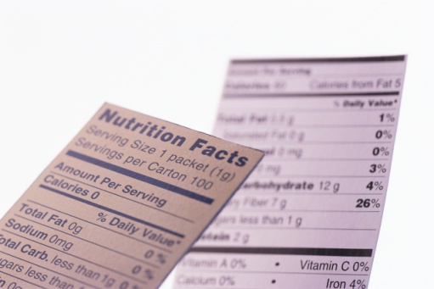
- Water

Scoring Rubric:

Preparedness for Workshop Classes 10
Quality of PowerPoint 10
Professionalism of Presentation 10
Knowledge of Subject Matter 10
Quality of Handout(s) 10
__
Total: 50

Due Date: _______________________________________

