North Korea's nuclear blast tests China's support

By Meagan Fitzpatrick, CBC News Posted: Feb 13, 2013 6:24 AM ET
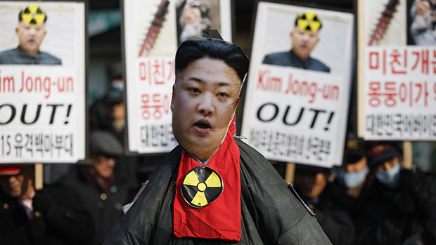

Activists from a civic group held a protest Tuesday following North Korea's nuclear test

near the U.S. embassy in Seoul. (Kim Hong-Ji/Reuters)

The underground blast set off by North Korea Tuesday was not just a nuclear test — it was a test for its only real ally, China, which is under new leadership and under international pressure to rein in its neighbour.
After the earth in North Korea rumbled Tuesday morning, eyes quickly turned next door to China to see how Xi Jinping's administration would react to what some analysts are calling a slap in the face.
China, a longtime provider of food, fuel and other support, had warned North Korea not to carry out its threat to conduct a third nuclear test — but leader Kim Jong-un obviously didn't take the advice. China broke away from its ongoing New Year celebrations to react to the news.
First the foreign ministry issued a statement saying China was "firmly opposed" to the act and urged North Korea to refrain from doing anything that would "further worsen the situation." China's statement said it wants peace and stability in the region and a denuclearized Korean peninsula.
Then China made a visible show of its displeasure, The Associated Press reported, by calling in North Korea's ambassador for a dressing-down, a rare occurrence. It also signed off on the statement issued by the United Nations Security Council after its emergency meeting Tuesday that said it will pursue a new resolution that contains "appropriate measures."
"This development is unwelcome from China’s perspective," Daniel Pinkston, an expert on Korea at the International Crisis Group, said about Tuesday's test. China is focused on its domestic modernization and economic development, according to Pinkston, and it needs and wants stability on its borders.
North Korea's recent actions of launching a rocket in December and now conducting another nuclear test aren't fitting with China's plans to maintain the status quo. But as Tuesday's defiant test clearly demonstrated, China isn't pulling much weight with Pyongyang these days.
"North Korea is not going to simply do what China tells them to do or what anyone else tells them to do," said Pinkston. "I think people, particularly in the West, overestimate the influence that China can have in disuading North Korea from conducting these types of tests."

'How far are they willing to go?'
Perhaps actions will speak louder than words, then, and China will move to cut off some of its aid that helps keep North Korea afloat while it is isolated from the West. But reducing the flow of trade, investment and goods wouldn't only hurt North Korea, but China itself and the companies that are profiting from the business.
"It raises the question, how far are they willing to go?" said Pinkston.
China doesn't want North Korea to implode — particularly because the United States and South Korea are key allies — but its willingness to prop it up could be waning. It has some decisions to make in the days ahead. Some China analysts are saying they don't expect China to abandon its ally, but that it will take stronger measures in response to this test than it ever has before.
China is a different country than it was the last time North Korea carried out a nuclear test in 2009, or before that in 2006.
"China's interests are changing in this region," said Ted Lipman, Canada's ambassador to North Korea and to South Korea until 2011. Lipman, who now lives in Hong Kong, said China's economic interests in the region would be threatened by greater instability caused by North Korea's nuclear ambitions.
China is being forced to reassess its interests and will likely take its time in making any policy changes toward its neighbour, he said.

Xi still fresh on the job
Lipman's doubtful that North Korea would actually point and shoot a nuclear missile at one of its enemies. The broader concerns are that having that capability would prompt an arms race in the region, and that the technology could fall into the wrong hands, he added.
The political landscape in Asia is also far different now than in 2009, with new leaders in key countries. This is the first test conducted under Kim Jung-un, who took over when his father Kim Jong-il died in late 2011. The young leader had generated hopes that he would steer his country in a different direction but optimism started to fade with December’s rocket launch.
Xi Jinping is still fresh on the job as China's top leader and Japan elected a new prime minister, Shinzo Abe, in December. South Korea is also in the midst of a leadership change, president-elect Park Geun-hye will take office later this month.
Paul Evans, a professor at the Institute of Asian Research at the University of British Columbia, said North Korea is following its usual pattern of behaviour, but the other countries are changing.
"The new factors are the most nationalist government in Japan in a generation and a senior Chinese leadership increasingly frustrated with North Korea and likely to participate in tougher sanctions against the North, in part to demonstrate a responsible commitment in an era of increasing tension on its maritime borders," said Evans, who is currently based in Hong Kong.
The leaders of Japan, China and South Korea are already dealing with existing tensions among their own countries — they are all fighting with each other over disputed sets of islands for example — and now they have the added challenge of responding to a regime that has taken another step towards arming itself with a nuclear weapon.
The rest of the world is watching them closely.
FOOD FOR THOUGHT:
According to THE ARTICLE:
- What is an even BIGGER concern than North Korea actually “pointing and shooting” any nuclear missiles? (Knowledge/Understanding)

- What would be some possible backlash if North Korea continues their nuclear development and testing? (Knowledge/Understanding)

According to YOU:
- It is your generation that can make a difference, right? How can you folks make the world see that nuclear missile development is a very bad idea? Or, if you think it’s a good idea, how can you get that message out to the world? (Analyzing/Evaluating)

