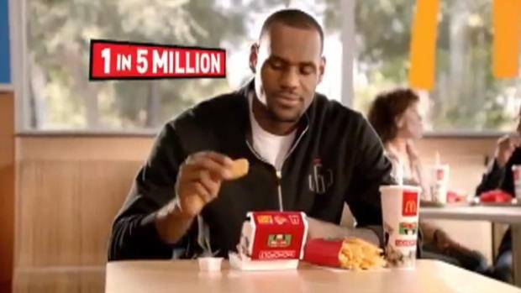
Athletes in junk food ads send kids mixed messages

Promotion of nutrient-poor food by athletes 'ironic'
CBC News Posted: Oct 04, 2013 6:37 PM ET Last Updated: Oct 07, 2013 8:03 AM ET
Professional athletes are promoting unhealthy food and drinks through product endorsements that send mixed messages to children about diet and health that should be reconsidered, public health experts argue.
In Monday's issue of the journal Pediatrics, researchers evaluated the nutritional quality of products endorsed by celebrities including:
- McDonald's and Sprite by LeBron James from the NBA.
- Gatorade and Pepsi-Cola by Peyton Manning from the NFL.
- Kraft Oreo cookies and Gatorade by tennis player Serena Williams.
- Gatorade and Tim Hortons by NHL player Sidney Crosby.
Marie Bragg of the Rudd Center for Food Policy and Obesity in New Haven, Conn., and her co-authors found 79 per cent of the 62 food products in advertisements endorsed by athletes were dense in calories and poor in nutrients, based on a nutrient profile used to assess whether products can be advertised to children in the United Kingdom.
About 93 per cent of the 46 advertised beverages had 100 per cent of their calories from added sugar.
"The promotion of energy-dense, nutrient-poor products by some of the world's most physically fit and well-known athletes is an ironic combination that sends mixed messages about diet and health," the study's authors said.

Researchers included Sidney Crosby's endorsements for Tim Hortons, Dempsters Bread and Gatorade as an example of a top athlete promoting food and beverage brands. (Hans Pennink/Associated Press)
"Professional athletes have an important opportunity to promote the public's health, particularly for youth, by refusing endorsement contracts," that promote junk foods.
The authors also called on governments worldwide to consider policies that restrict food advertisements featuring pro athletes in media targeted at youth.
A previous study suggested athlete endorsements are associated with higher ratings of healthfulness for the products.
Bragg's team said that with growing public pressure, such as criticism of the sponsorship of the 2012 London Olympics by McDonald's and Coca-Cola, it may be become a liability for athletes to endorse unhealthy foods and beverages.
Dr. Yoni Freedhoff is a family doctor and obesity expert who agrees with the researchers about rejecting endorsements of junk food by sports celebrities.
"My hope is this is a bit of an eye opener for the celebrities," Freedhoff said. "Over time, it will be seen as an awful thing for a celebrity to lend their name to the marketing of junk food."
Food For Thought
- What affects is athlete endorsement of unhealthy foods having on the youth in our society? (Application Level)

- List three alternative food products/companies that you would consider suitable for athletes to endorse. Explain why you’ve selected each of these. (Synthesis Level)

Food Product / Company | Reason Selected
1.

2.

3.

