Group seeks to make O Canada's English lyrics gender-neutral

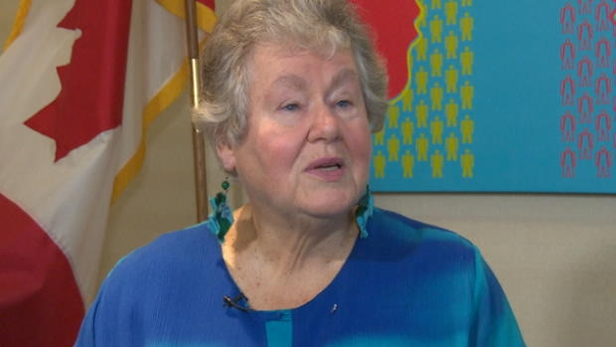
Margaret Atwood, Kim Campbell among those supporting change to lyrics
The Canadian Press Posted: Oct 01, 2013 12:15 PM ET
Last Updated: Oct 02, 2013 9:32 AM ET
A group of notable Canadian women is launching a campaign for gender-neutral language in the English lyrics of O Canada.
The group said the change would restore Canada's English national anthem to its original gender-neutral intentions.
The group — which includes author Margaret Atwood and former prime minister Kim Campbell — has set up a website to promote the idea.
It is calling on Canadians to join the campaign and encourage Prime Minister Stephen Harper's government to change the line "in all thy sons command" to "in all of us command."
The campaign won't be able to count on the Official Opposition for support, however.
NDP Leader Tom Mulcair said Tuesday in Ottawa that the anthem is "wonderful" and "extraordinary" as it is and shouldn't be altered when it comes to gender.
"I think that when you start tinkering with an institution like a national anthem, that you're looking for problems," he said when asked about the proposal.
"We seem to have agreed on the English and French versions as they are and I think that's probably a good thing."
RestoreOurAnthem.ca is being launched on the 100th anniversary of the change made to Judge Robert Stanley Weir's original English lyrics.
The coalition says for no documented reason the lyrics were revised in 1913 from "thou dost in us command" to "in all thy sons command" and that it is time to make a change to reflect the inclusive intentions of the original lyrics.
Other members of the group include Senator Nancy Ruth, retired senator, author and fashion designer Vivienne Poy and Sally Goddard, mother of Nichola Goddard, the first female Canadian soldier killed in combat.
"The words 'All thy sons command' in the English national anthem suggests that only male loyalty is being invoked," said Atwood.
"Restoring these lyrics to gender-neutral is not only an easy fix to make our anthem inclusive for all Canadians, but it's also long overdue."
Food for Thought

- Do you agree with author Margaret Atwood who believes that, as our national anthem exists now, only male loyalty is being declared through the words “All thy sons command”? Explain.

- Do you support changing our anthem to gender neutral language or do you feel it should remain as it has been since 1913? Support your answer.

