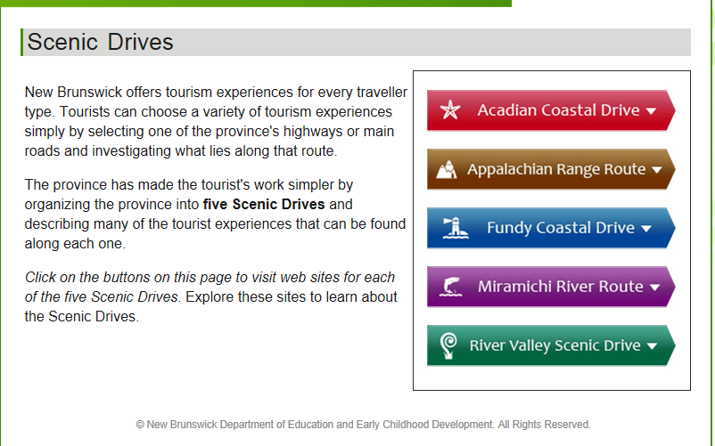

Go to:

<http://www.tourismnewbrunswick.ca/Learn/ScenicDrives.aspx>

Explore this website to learn about the Scenic Drives for New Brunswick.