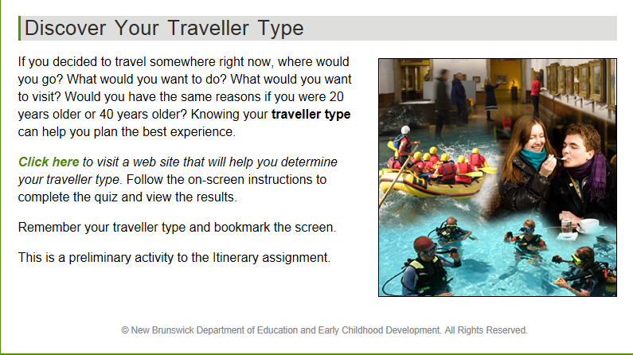
Go to the following website to determine your traveler type: www. http://quiz.canada.travel/caen.
Follow the on-screen instructions to complete the quiz and view the results. My Traveler type is ________________________________________

- Print off your results page that explains what your traveler type is. (You will use this for an upcoming project).
- Select the See All Traveler Types button
- Make a list of the 9 Traveler Types

