Fairy Tale Crimes

As in most literature, conflict is the central element of a fairy tale, and in many of those cases, the actions would be illegal under the Criminal Code of Canada. To review the concepts of Actus Reus and Mens Rea, as well as to give you a chance to look at the Criminal Code, this assignment asks you to suspend your disbelief in fairy tales and act as a prosecutor in the case of the Criminal Fairy Tales….

- Choose whether you will work alone or with a partner.
- Choose a fairy tale.
- Provide a brief overview of the story.
- Identify the crime(s) involved. Treat any animal/make-believe characters as human if they act in a human capacity (ie: Big Bad Wolf)
- Identify the actus reas elements of each crime.
- Identify the mens rea elements of each crime (Does it show intent, knowledge, negligence, recklessness or willful blindness? Explain.)
- Use the Criminal Code of Canada (either the book or online) to determine:
- Which section (s) of the Criminal Code would the perpetrators(s) be charged under?
- How is the crime defined in the criminal code? ( in other words, what does the section state?)
- What sentence could the guilty party receive if charged and convicted of this crime in Canada? What sentence do you recommend to the judge?

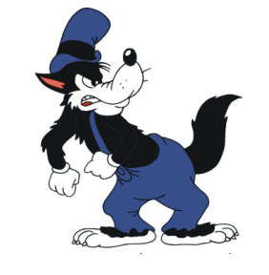
Grading:
Identify most of the crimes (10)
Criminal codes (10)
Elements of the crime explained (20)
Presentation style (creative) (20)

