Music 10
Music Styles Quiz Review

BLUES
Be familiar with:
- Sub styles of Blues (indicated on map)
- Topics of Blues
- History of Blues (when/where/who/why)
- Blues Map
- General topics of Blues songs
- Artist of each substyle
- Instruments featured

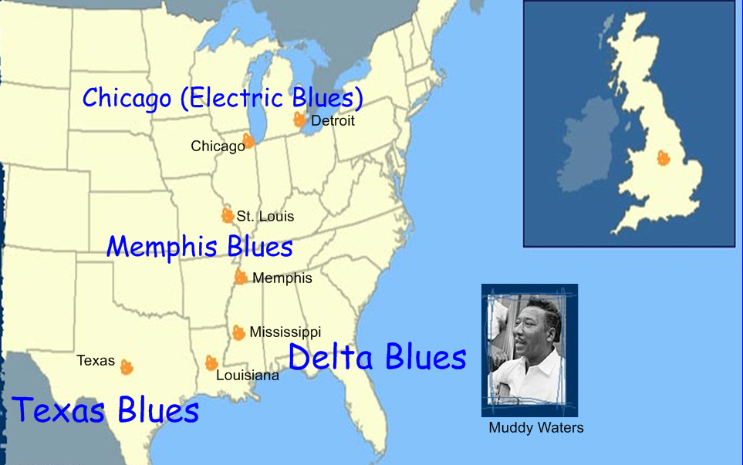

JAZZ
Be familiar with:
- Substyles of Jazz (Dixieland, Swing, Bebop, Cool, Fusion)
- Artists of each substyle
- Instruments featured
- Origins

ROCK n ROLL
Be familiar with important developmental events such as :
1950’s
- How “rock ‘n roll” got its name (Radio DJ Alan Freed)
- Pre-Rock Pop artists (Frank Sinatra, Doris day, Tony Bennett, etc.)
- How rock ‘n roll was introduced to white audiences
- Electric Guitar becomes commercially available
- 1955- Bill Haley and His Comets first group to have first nationwide #1 hit (Rock Around the Clock)
- 1957- Rock ‘ Roll records account for 43% off all records sold
- 1956- Elvis Presley’s first hit “Heartbreak Hotel”
- 1959- plane crash tragically kills Buddy Holly, the Big Bopper, Ritchie Valens

1960’s
- Television becomes important tool in promoting rock music
- Networks attract younger audiences
- Shows such as American Bandstand and Ed Sullivan Show showcase rock bands
- Outdoor music festivals such as Woodstock held in Bethel, New York, attract 500,000 people, in 1969
- Beatles dominate charts with 6 out of top 10 albums
- Songwriting moves beyond pop love songs and begins to include political statements
- Harder rock sound emerges and sows seeds for heavy metal

1970’s
- Beatles break up
- Deaths of Jimi Hendrix, Janis Joplin, Jim Morrison, all at age of 27
- Touring bands like Pink Floyd, The Who and Led Zeppelin fill arenas and perform for 1000’s of people
- 1977 Elvis Presley dies at the age of 42
- Car stereos become popular , followed by 8 track recorders, then cassette tapes
- Due to a wide variety of radio stations, several new styles of rock emerge such as :
  - Singer songwriter
  - Soft rock
  - Punk rock
  - Disco
  - Reggae

Refer to Powerpoint notes for 1980’s-2000’s

For each decade be familiar with:
- top selling Rock artists

