Ebola outbreak prompts nation-wide lockdown in Sierra Leone

Likely the largest lockdown in recent history, WHO says

The Associated PressPosted: Sep 19, 2014 9:36 AM ETLast Updated: Sep 19, 2014 7:34 PM ET
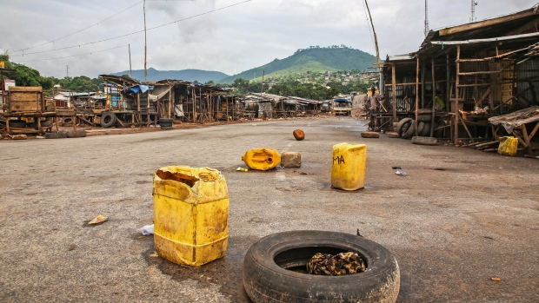
More than six million people are currently under lockdown in Sierra Leone, leaving normally bustling markets and streets empty. (Michael Duff/Associated Press)
Sierra Leone confined its 6 million people to their homes Friday for the next three days as the Ebola-ravaged West African country began what was believed to be the most sweeping lockdown against disease since the Middle Ages.
In a desperate effort to bring the outbreak under control, thousands of health care workers began going house to house in crowded urban neighbourhoods and remote villages, hoping to find and isolate infected people.
President Ernest Bai Koroma urged his countrymen to co-operate.
"The survival and dignity of each and every Sierra Leonean is at stake," he said Thursday night in an address to the nation.
Health officials said they planned to urge the sick to leave their homes and seek treatment. There was no immediate word on whether people would be forcibly removed, though authorities warned that anyone on the streets during the lockdown without an emergency pass would be subject to arrest.

'Many of our people have died'
More than 2,600 people have died in West Africa over the past nine months in the biggest outbreak of the virus ever recorded, with Sierra Leone accounting for more than 560 of those deaths.
Many fear the crisis will grow far worse, in part because sick people afraid of dying at treatment centres are hiding in their homes, potentially infecting others.
However, international experts warned there might not be enough beds for new patients found during the lockdown, which runs through Sunday.
Most people seemed to be taking the order seriously, and there were no immediate reports of resistance.
"It will protect our country from this dangerous virus," said Ishmail Bangura, a Freetown resident. "Many of our people have died — nurses and doctors, too — so if they ask us to stay home for three days, for me it is not bad."

Attacks on aid workers, journalists
Across West Africa, health care workers have been attacked by villagers who accused them of spreading Ebola. Some citizens have also violently resisted efforts to quarantine them.
In the latest case of violence against health care workers, six suspects have been arrested in the killings of eight people in Guinea who were on an Ebola education campaign, the Guinean government said Friday.
The victims were attacked by villagers armed with rocks and knives. The dead included three local journalists.
As the lockdown took effect, wooden tables lay empty at the capital's usually vibrant markets, and only a dog scrounging for food could be seen on one normally crowded street in Freetown.
Amid the heat and frequent power cuts, many residents sat on their front porches, chatting with neighbours.
Ambulances were on standby to bring any sick people to the hospital for isolation. The health care workers also planned to hand out 1.5 million bars of soap and dispense advice on Ebola.
"We hope and pray that when we talk to people they will take it as counselling," said Rebecca Sesay, a community Ebola education team leader. "That is why we are all out here."

Largest lockdown in recent history
The World Health Organization said it has no record of any previous nationwide shutdown of this scale and suggested it has not happened since the plague devastated Europe during the Middle Ages.
The closest parallel seems to have been a plague scare in India in 1994, when officials closed off a region around the city of Surat, shutting down schools, offices, movie theatres and banks.
UNICEF said the government campaign provides an opportunity to tell people how to protect themselves.
"If people don't have access to the right information, we need to bring lifesaving messages to them, where they live, at their doorsteps," said Roeland Monasch, UNICEF representative in Sierra Leone.
In a statement, the UN children's agency said the operation needs to be carried out "in a sensitive and respectful manner."
FOOD FOR THOUGHT:
In addition to what you learned in the Article of the Week, please know that Canada is sending $2.5 million for specialized protective equipment (used to protect health-care workers) and the U.S. is sending military personnel and building treatment centres as a response to this outbreak. Here’s this week’s food for thought: Why? Should Canada and the U.S. intervene, or is this simply the human race “culling the herd”? Should we intervene, or should we let nature run its own course? (Evaluation level)

