- THOUGHTFULLY PROVIDE NOTATION ON THIS ARTICLE TO SHOW EVIDENCE OF YOUR THINKING THROUGHOUT YOUR READING (test-to-self, text-to text, text-to-world, and vocab strategies).
- RESPOND TO THE “food for thought” SECTION BELOW THE ARTICLE.
ARTICLE #1 from CBC.ca. posted September 15, 2014

Lethbridge student selling Pepsi suspended for good reason, says school board

Keenan Shaw says he was suspended for selling Pepsi from his locker to other students

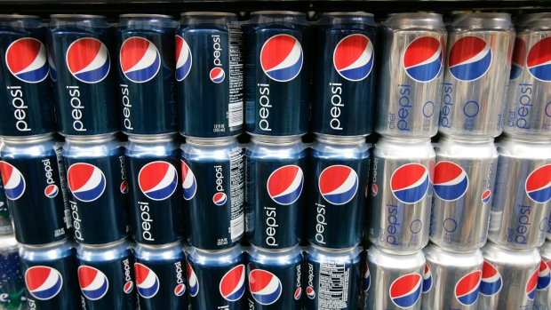

School board administrators in Lethbridge, Alta., are defending their suspension policies after a Grade 12 student refused to stop selling Pepsi out of his locker.
Keenan Shaw was suspended for two days by Winston Churchill High School. He was selling the soft drink to students, which violated several school policies.
Cheryl Gilmore, superintendent of the Lethbridge public school board, said Monday she can't speak about the student's case but the rules say a principal has to be consulted before an item can be sold in school.
The board's nutrition policy also prevents the sale of sugary pop at schools.
"We can't just have anyone coming into the school selling anything they want in the school," she said.
"There's a distribution of merchandise policy, but we would never suspend someone. We would talk to them about it, we would talk to them about why it doesn't follow our nutrition policy. So there would be lots of talk and fair warning, and opportunity to work with the school administration, before it would ever get to the point of a suspension."
While selling a Pepsi isn't enough for a suspension, Gilmore said "persistent or chronic disobedience or disregard for district or school rules" is.

Student upset with suspension
Shaw says he was told the sales violated the nutrition and marketing policies, and that he was operating a business without a licence.
But compared with what some other students sell at the southern Alberta school, Shaw says his transgressions were minor.
"I'm not going to name any names, but I know a couple of people selling marijuana," he said.
"There's kids selling smokes, there was a kid last year selling meth, as well as a kid selling acid."
Shaw says he has been told he will be expelled if the pop sales continue.
His mother says she believes the school went a little over the top and that the punishment is too extreme.
Article #2 from CTVnews.ca, posted September 17th, 2014
Teen suspended after selling non-diet pop from his locker
The entrepreneurial skills of an Alberta teenager are making headlines after he was suspended for selling non-diet pop out of his school locker.

Keenan Shaw, 17, didn't think he was doing anything wrong when he started selling Pepsi to his friends and classmates at Winston Churchill High School in Lethbridge, Alta.

He said he started selling regular pop because his school only allows diet pop. Shaw figured, if he wanted regular pop, other students probably would want one too.
But Shaw's operation was soon shut down by school officials who told him to stop, issued a warning and then briefly suspended him last week.

Lethbridge School District Supt. Cheryl Gilmore said there are many factors to consider when suspending a student and it would be unreasonable to keep Shaw out of the class for an extended period of time.
"Students have it explained to them why they need to follow certain rules, and then we're hopeful that like any other public institution, that the people who are in that institution kind of understand that those have to be followed," she told CTV Calgary.
She also said that the district has specific policies for advertising, distribution, and merchandising within schools.

But Shaw told CTV Calgary that he simply saw a good business opportunity and ran with it. He even started accepting IOUs as payment for the pop until school officials told him to stop.
Shaw's short-lived business made local and national headlines. And then it made its way onto late-night TV.

Comedian and late-night TV talk show host Seth Meyers recently poked fun at Shaw's punishment.
"A student at a Canadian high school was suspended for illegally selling Pepsi out of his locker to other students. It's being called the worst crime in Canadian history," Meyers joked.

As for Shaw, he said the attention was kind of funny at first, but he never thought it would go beyond the local community.

"I thought it was pretty funny. I didn't think it would go beyond local stuff… it's gotten a lot bigger than I thought it would," he said.

Food for Thought:

We had you read two short articles on the same basic story to see if you can identify an author’s bias in a piece of writing. Often, there are two sides to a story, and writing sometimes favours one side over the other. Bias is simply the slant towards one side, and writers sometimes don’t even realize it is there.

One of these stories seems to slant slightly towards the student’s side, while the other seems to slant towards the side of the school district. Using the chart on the back of this sheet, try to identify the bias in each story, then list two things each author did to slant it that way (they might not even know they did it……..)

Article #1 from CBC seems to be biased towards _____________________ | Article #2 from CTV seems to be biased towards _____________________
Here are a couple of things the author did to slant it that way:  1)  2) | Here are a couple of things the author did to slant it that way:  1)  2)

