Teen boy sues DMV after being forced to take off his makeup
by Lauren O'Neil Posted: September 3, 2014 7:29 PM Last Updated: September 3, 2014 5:33 PM
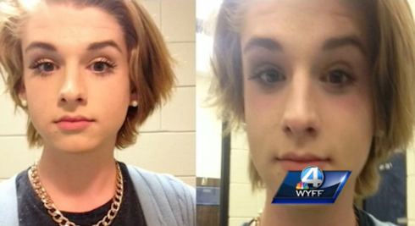

Long lines, grumpy workers, forcing yourself not to smile while camera bulbs flash in your face... Most people would agree that having photos taken for a piece of government-issued ID can be a traumatic experience.
It's not likely that 16-year-old Chase Culpepper expected to have the time of his life when he went to a South Carolina DMV for his first driver's licence photo in March — but he didn't expected to leave feeling humiliated, either.
According to the Associated Press, the gender non-conforming teen (who identifies as male) has filed a lawsuit against the state's suing the Department of Motor Vehicles for forcing him to remove his makeup in order to obtain a licence.
Culpepper, who wears androgynous or women's clothing and makeup nearly every day, was reportedly told by DMV officials that his makeup could be considered a "disguise," and that it was in violation of a policy that bans pictures where "someone is purposefully altering his or her appearance."
"It was very hurtful," said the teen's mom Teresa Culpepper, who filed the suit on his behalf, to WYFF in Anderson, SC. "He was absolutely devastated. That's who he is 24/7."
Culpepper, who had already passed his driving test, eventually conceded to the DMV officials' request that his makeup be removed at the time so that he could get his driver's license.
But he wasn't about to let the way he was treated go unrectified.
On Tuesday, with the assistance of a New York group known as the Transgender Legal Defense and Education Fund, Culpepper and his mother filed a lawsuit against the DMV alleging that the agency committed sex discrimination, as well as violated the teen's First Amendment right to free expression.
The suit's primary complaint was against a 2009 DMV policy cited by employees while refusing to take Culpepper's photo with makeup on.
The policy indicates that "at no time will an applicant be photographed when it appears that he or she is purposely altering his or her appearance so that the photo would misrepresent his or her identity."
Michael Silvermen, the Transgender Legal Defense and Education Fund's executive director, said that this policy "lets DMV employees arbitrarily decide how men and women need to look without regard for the rights of the people that they are supposed to serve."
"Chase Culpepper is entitled to be himself and to express his gender non-conformity without interference from the South Carolina DMV, Silverman continued in a statement provided by his organization. “It is not the role of the DMV or any government agency or employee to decide how men and women should look. Chase should be able to get a driver’s license without being subjected to sex discrimination.”
The lawsuit asks that Culpepper be allowed to have his driver's licence photo re-taken while wearing his regular, everyday makeup.
It also asks that the DMV policy be struck as " unconstitutionally vague."
“I want to take my license photo again, with makeup, so I can be myself and express to the world who I truly am,” Culpepper said in the TLDEF statement. “The Department of Motor Vehicles should not have forced me to remove my makeup simply because my appearance does not match what they think a boy should look like. I just want the freedom to be who I am without the DMV telling me that I’m somehow not good enough.”
Corresponding Questions:
- Why was Chase Culpepper asked to remove his makeup before having his photo taken? (Knowledge

- Do you think Chase Culpepper will be granted the opportunity to have his photo retaken wearing makeup? Why or why not? (Analysis)

- Did the DMV treat Culpepper fairly? Explain. (Evaluation)

