The Elements of Music

The elements of music are those things that make a style of music sound the way that it does.
DYNAMICS
Volume level, and changes in that level. In classical music the terms used to describe dynamic levels are often in Italian.

RHYTHM
Rhythm is the element of time in music. When you tap your foot to music, you are “keeping the beat” or following the rhythmic pulse of the music. There are several important aspects of rhythm:
DURATION: how long a sound (or silence) lasts
TEMPO: the speed of the BEAT, which can be described by the number of beats per second (or in Classical music by standard Italian terms)

METER: When beats are organized into recurring accent patterns, the result is a recognizable meter. The most common meters are diagrammed below.
Conducting Patterns

MELODY
Melody is a succession of sounds (pitches) and silences moving through time. Melodies can be thought of as movement in sound (unison, step, skip, leap). A melody is the part that you might hum to yourself as you remember the song.

TONE COLOR (or TIMBRE – pronounced “TAM-BER”)
If you play a “c” on the piano and then sing a “c”, you and the piano have obviously produced the same pitch – but why doesn’t your voice sound like the piano? It is because of the laws of physics and musical acoustics. Composers use timbre much like artists use colors to evoke certain atmospheres on a canvas. So instruments are sometimes referred to as tone colors.

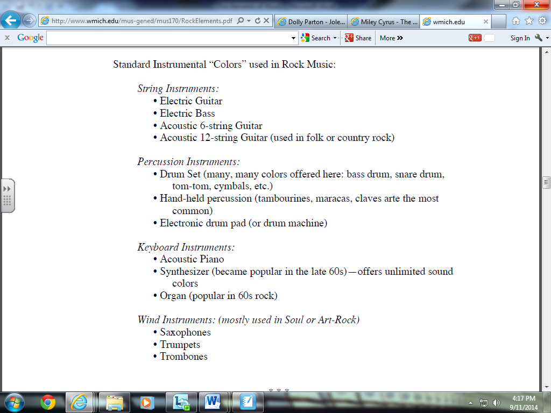

FORM
Most musical works are divided into a series of sections, which together make up the form(or “structure”) of the work. Like in poetry, there are some standard forms such as binary form (AB Form); rondo; ternary form (ABA); theme and variations; twelve bar blues. Vocal music often follows the form of its text.

MOOD
The mood is the aspect of the music that is affective. I make you feel an emotion. Researchers in the field use the term “music emotion” or “music mood” to refer to the affective aspects of music. The study and classification of moods or emotion is called Music Psychology.
Mood List
Dark Dramatic Intense Fervent Calm
Light Fun Cheerful Tranquil Energetic
Fiery Aggressive Relaxed Emotional Angry

