Marketers are Targeting You
According to a 2007 study, North Americans living in urban centers are exposed to over 5000 ads per day. This number would be much higher today, considering the ads we see on mobile devices, video games and social media apps and sites.

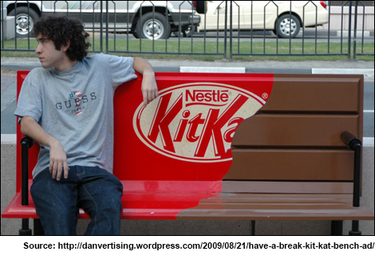
The competition to create an ad that catches your interest is fierce! The following list includes some of the techniques that marketers use to target consumers.

- Ambient Advertising
"Ambient" refers to anything that surrounds you, such as the ambient music in a mall, or the ambient temperature outdoors. Ambient advertising describes advertising that uses new and imaginative locations and forms to take advantage of those spaces where traditional advertising doesn't usually appear. Ambient advertising includes giant ads ("wrappers") on the sides of city busses, the little stickers on bananas, ads on park benches and bus shelters, and ads pasted to store floors, taxis and public washroom walls.

- Stealth Endorsers
For decades, celebrities have been paid to advertise products and services ranging from sneakers to insurance policies to medication. In recent years, some advertisers have felt that the public is learning to ignore the sales pitches of famous people who are obviously paid to promote something whether or not they like or use it. To avoid turning buyers off, advertisers are using a new technique to use celebrities to sell products: stealth endorsement. They pay celebrities or other popular individuals (like bloggers) to secretly (stealthily) be seen using certain products when spotted (and photographed) in public. This can include being paid to post videos online that look like regular user videos—not intentional advertisements. In this way, the endorsers appear to sincerely prefer and use the product.
- Naming Rights
Quickly: think of the name of any major sports or entertainment arena or stadium. The chances are that it is named after a major company. Corporations often pay to have the naming rights for high-profile public places (including parks, schools, libraries and museums) to keep their names in the public's mind, and associated with positive, trusted images. The cost of purchasing naming rights can be very high, making this practice appealing to organizations and governments looking for new revenue
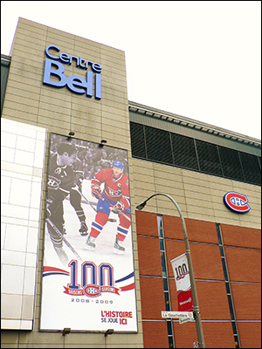

- Targeted Advertising
Have you noticed that the ads you see on the Internet often reflect pages you recently visited, or purchases you recently made online? This is an example of targeted marketing, where advertisers collect information about you and then send targeted ads that match your interests directly to you. Targeted advertising can be far more effective than randomly broadcast ads, making it profitable for companies to gather information on people so they can target ads to individuals. In this way, pregnant women may be surprised to receive coupons for expectant moms before their baby is born, and then coupons for diapers after the baby is born.
- Cross Merchandizing
Cross merchandising is displaying products of similar or different categories in the same area, in order to increase sales. For example, displaying batteries next to flashlights. Another example would be a store mannequin dressed to display a featured brand of jeans also wearing a shirt and shoes that the store sells.
Cross merchandising also refers to how large media companies market various products of the same theme across their various media formats. For example, in 2012, Lionsgate films used a social marketing campaign to promote The Hunger Games. Using apps, YouTube videos, Facebook and Twitter pages millions of followers watched videos, favourite tweets and liked pages. This was all part of generating buzz for the books and films, and sales for various Hunger Game products. Click here to read an article about cross marketing.

- Product Placement
Product placement is as simple as it sounds: products are placed (for a fee) in movies, television shows, music videos and video games where they seem to be natural parts of the set or the action. Just as stealth endorsers are supposed to fool viewers into thinking a product appears naturally, rather than as a paid ad, product placements are designed to make you think a product "belongs" in a certain setting. Although viewers are catching on to product placements, we should expect them to increase, as technology enables us to skip over traditional advertisements. You can have some fun with product placements when you watch a show by noticing whether you ever see both Pepsi and Coke in the same show, or whether the car logos are clearest in the hero's or the villain's car. Click here to read about product placement in music videos.

- Digital Advertising
Digital advertising refers to using technology, social media and the Internet to attract consumers. This form of advertising includes electronic billboards in sports arenas, digitally inserting a product logo or content on the ice during a hockey game, and even inserting specialized ads into scenes from TV shows, movies, video games and apps. Custom or targeted digital ads can also be delivered to computers, tablets and smartphones. For example, during the 2013 Super Bowl, the power went out during the game. An advertising company employed by Oreo quickly tweeted an image that worked perfectly with the unexpected situation. That one tweet cost no money, but caused more buzz about the Oreo brand than the millions of dollars they had invested in their Super Bowl advertisement. Click here to see and read about the Oreo tweet.

