The Media's Forms, Codes and Conventions

**The mass media also use forms, codes and conventions to add important information to their messages, and to increase their effectiveness.**

Watch the following clip, as it provides a breakdown of the codes and conventions used in psychological thrillers.

https://www.youtube.com/watch?v=LiyEL7843IM

[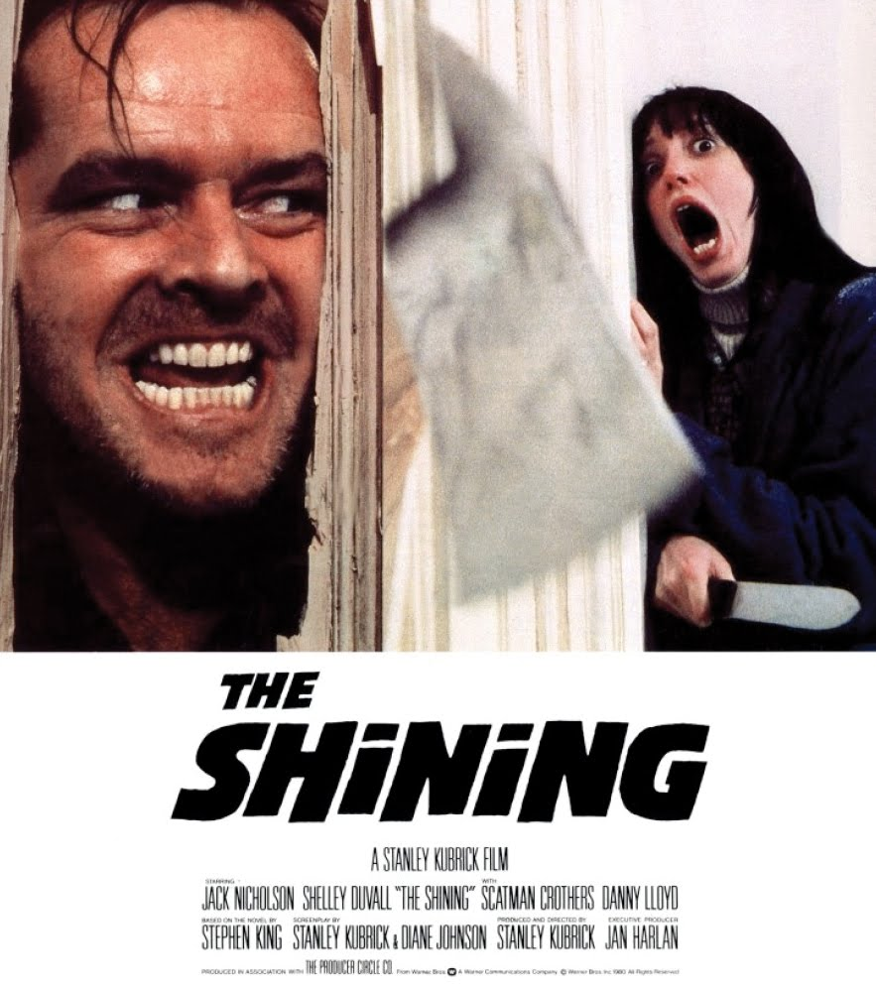](http://www.google.com/url?sa=i&rct=j&q=&esrc=s&frm=1&source=images&cd=&cad=rja&uact=8&ved=0CAcQjRw&url=http://wordofthenerdonline.com/2014/10/halloween-14-shining/&ei=-vnQVMmjHoGVyATRlIKIBA&bvm=bv.85076809,d.aWw&psig=AFQjCNE9ddWS37hxZgtk_xoVAb6XM3G3og&ust=1423068018707743)

These things we do that convey additional information without words or explanation are called:

**forms** - Stand-up comedians use a communication form that is entirely different from the form used by people giving political speeches.

**codes** - The wink-and-a-nod is code for "Just kidding."

**conventions** - The abbreviations and clever short forms we use in text messages are very different writing conventions from conventions used in business letters.

Each of us modifies how we communicate in certain situations to transmit our messages more effectively. We use a different tone of voice when visiting a grandparent than we do when skiing with friends. We know that a loud, urgent tone makes a warning more effective. When calming a child, we know that a quiet, gentle voice means "Don't worry, it will be OK." We know that a wink-and-a-nod tells a listener to not take what we just said seriously, and speaking with a lowered head and downturned eyes and mouth means regret.

