Media and the Construction of Reality

In the example of the exchange student, we can say that the sender (the student) constructed a specific "reality" for the receivers (her parents). While her apparent message is not false (she really did enjoy sunny, safe activities and earn high marks), it is an exaggerated reality because it only shows selected views of her actual summer. It does not include pictures taken at parties or on crowded subways, or images of her recovering from a fever or arguing with her host family. It is a constructed reality.

The suggested meaning of any media message may also include a constructed reality. Senders can use a series of messages to build this constructed reality or to reinforce it.

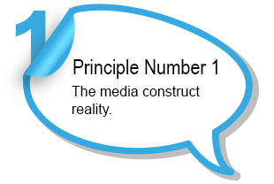

Take a moment to consider what reality the following senders of media messages might want to create:

* ***A television news station***
* ***A New Brunswick teen writing a love letter to his girlfriend attending university in Alberta***
* ***A charitable organization that provides artificial limbs to child victims of war***
* ***A writer of teen adventure novels***
* ***A political party***



Consider a print ad for Disney World that shows a smiling family having fun. The apparent message and the suggested message are both that families have fun at Disney World. By keeping this message in mind whenever they design ads, the company creates and reinforces the constructed reality that Disney World is always fun for families. This constructed reality does not include long lines, people suffering in the heat (or rain), or screaming children.