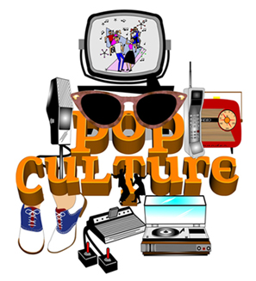

**Gangnam Style** is a 2013 Korean music video that "went viral" and was quickly copied, mimicked and lampooned worldwide. To view the video, [**click here**](http://knowyourmeme.com/memes/psy-gangnam-style).

A **flash mob** is a sudden, planned gathering of people in a public place to perform a coordinated action (usually for entertainment purposes), and then leave. Flash mobs are a 21st century meme that often appear in Internet videos of groups gathering in malls, train stations or other open areas to sing, dance or perform music. [**Click here**](https://www.youtube.com/watch?v=JdLvUkLW5Jk) to watch an example done by the cast of *The Big Bang Theory*

We all know the **selfie**: the photos we take of ourselves, alone or with a friend, and usually with part of our arm in the shot. Digital cameras make it simple and free to snap endless pictures, and Facebook gives us a medium for sharing them. To view Wikipedia’s entry on the selfie, [**click here**](http://en.wikipedia.org/wiki/Selfie).

Elements of pop culture include the popular ideas, music, images, trends, games, books, celebrities, sayings, fashion, and movies. An important element of pop culture is its current ***memes*** (rhymes with "seems"). **A meme is any behaviour, style, idea, or way of using or doing something that spreads rapidly through a culture.** For example, the Harlem Shake became an instant meme in 2013. That year, the Internet was suddenly filled with videos take-offs of the original Harlem Shake video. Click here [https://www.youtube.com/watch?v=DAOqKM4wou4](https://www.youtube.com/watch?v=DAOqKM4wou4%20) to see the Simpsons getting involved in the craze. Memes appear and change rapidly. Some become nearly permanent in a culture; others vanish suddenly.

Popular culture, also known as ***pop culture*, refers to all the things that are popular in mainstream society.** Mainstream society refers to the masses of people in a culture, and so pop culture belongs to "the masses," not to any one special group or class of people. In addition, ***pop culture*** changes as rapidly as the masses change their interests. The opposite of pop culture would be a culture that tries to preserve and continue the activities, beliefs and values of previous generations while the world around it changes.

***Can you think of a person, or a group that practices this? Is it common?***