The Internet, and an ever-growing mass media enable memes and other pop culture elements to spread and change faster, and to spread farther. Pop culture used to be associated mostly with Western culture; however, today it spreads around the world and is influenced by people from every part of the world. The popularity of social media (that's yet another meme) adds to this spread.
ACTIVITY
This activity lets you test your knowledge of pop culture trivia. Two examples of pop culture from each decade since the 1940s appear in the left column. See if you can identify the decade each belongs to

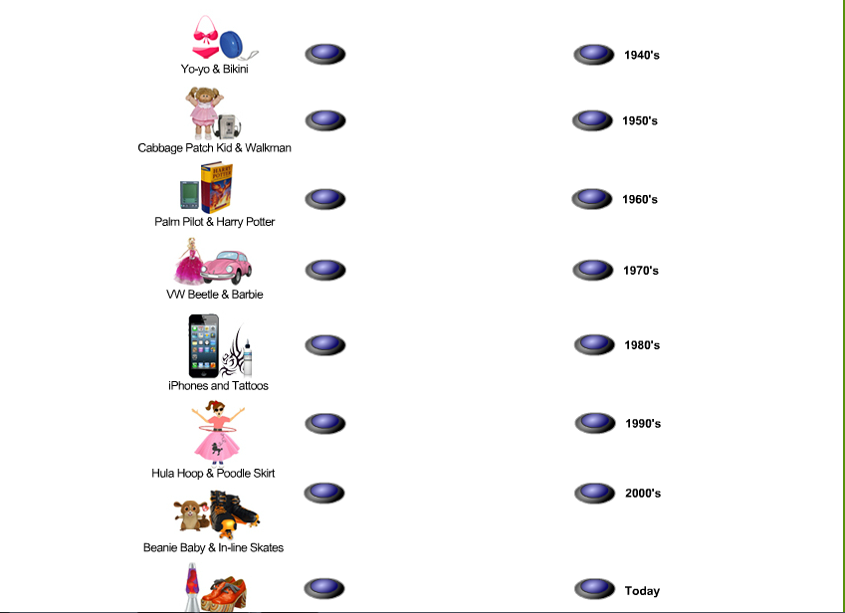
“Battle of the Decades” Project

Popular culture is defined as the arts, artifacts, entertainers, fads, beliefs, and values shared by large segments of society. Unique popular cultures can be seen for each decade in history. For example the 20’s saw the dawning of a new genre of music called jazz and in the 80’s toy store shelves were stocked with new products: Cabbage Patch Kids and Strawberry Shortcake. What’s interesting is that we are seeing these products make a revival in the new millennium and they are as popular now, if not more, than they were at their inception in the 80’s.

Your task:
With a partner you will convince, induce, persuade, and prove beyond a shadow of a doubt that the decade you are representing is the “Ultimate Decade of Pop Culture”. You will be designated a decade to research and represent. You will present a creative display of your decade using a PowerPoint slideshow, *costumes, music, food, and other creative techniques. Topics, which you should consider, are:
- Music
- Fads
- Toys
- Vehicles
- Hairstyles
- Slang
- Fashions
- Top entertainers
- Other points of interest

The winning group will be awarded the prestigious “Battle of the Decade” award, which is a renowned honor in the world of Media Studies.
MAY THE BEST DECADE WIN!!

