Review for Test #3: Answer Key

Pg 217
2:B
4:D
6:A
7:D
16:Carbon dioxide +water----- sugars + oxygen

Pg 237
1:C
2:B
3:B
4:C
14:oxygen + glucose ---- carbon dioxide + water + oxygen

3. Two layers of lipid molecules

4. Movement of particles from an area of high concentration to an area of low concentration

5. Osmosis is the diffusion of water through a selectively permeable membrane.

6. Hypertonic =larger concentration of solute, hypotonic= smaller concentration of solute, isotonic= concentration is same throughout

7. Hypertonic= water from the cell will move out of the cell, possibility of the cell shrinking
Hypotonic= water from the solution will move into the cell, possibility of a burst cell
Isotonic= water will move into and out of the cell at the same rate

8. Facilitate diffusion requires the use of protein transports

9. Facilitated diffusion involves particles moving from high to low concentration and does not require any energy. Active transport involved particles moving from low to high concentration and requires energy (ATP) from the cell.

10. Endocytosis= substances moving INTO the cell
Exocytosis= substances moving OUT OF the cell

11. Pinocytosis= liquid being moved into the cell
Phagocytosis= particles being moved into the cell

12. To provide the cell with energy through the conversion of glucose.

13. Process that releases energy by breaking down glucose in the presence of oxygen.
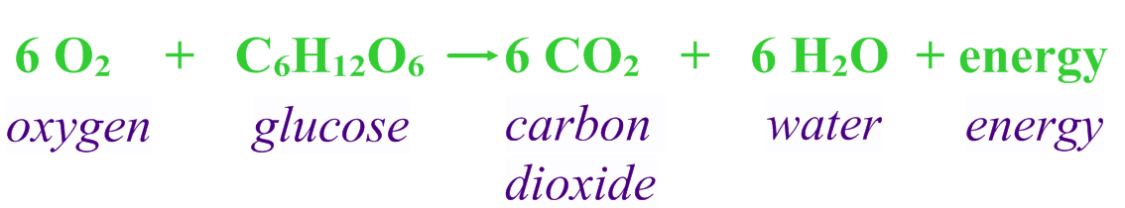

14. To make food (glucose) for the cell through the energy of the sun, water and carbon dioxide.

15. Process that uses the energy from the sun to convert water and carbon dioxide into high energy sugars and oxygen.
