Answer Key
Cell Structure and Function
Review Questions
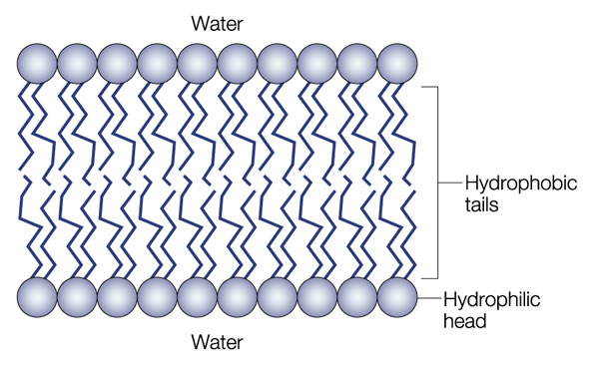
- Sketch and label a diagram of the cell membrane. Label the following components (hydrophilic tails and hydrophobic heads, protein channels )

- Describe the process of diffusion.
Diffusion is the movement of particles from higher concentration to low concentration, through a membrane.
- What is the relationship between osmosis and diffusion?
Osmosis is the diffusion of water.

- Distinguish between hypertonic, hypotonic and isotonic solutions.
Hypotonic= a solution with a lower concentration
Hypertonic= a solution with a high concentration
Isotonic= solutions that have the same concentration

- Describe what happens to a cell when placed in each of the following solutions:
  - Hypertonic
  - Hypotonic
  - Isotonic

- Explain the difference between facilitated diffusion and active transport. Be sure to indicate whether or not each process requires energy.
Facilitated diffusion is the movement of particles from an area of high concentration to low concentration. It does not require any energy.
Active transport is the movement of particles from an area of low concentration to high concentration, it requires energy.
- Distinguish between endocytosis and exocytosis
Endocytosis is the movement of material into the cell; whereas, exocytosis is the movement of material out of the cell.
- What organelles are unique to the animal cell and the plant cell?
Plant= Cell wall, chloroplasts
Animals= centrioles, lysosome

