Review for Test #4: Answer Key
Pg 545
1:A
2:B
7:C
12: Hyphae are tiny filaments that are only one cell thick, whereas a mycelium is a thick mass composed of many hyphae tangled together
15: Spores must land in a favorable environment. There must be the proper combination of temperature, moisture and food.

575:
1:B
5:D
6:B
9:C
24:Fruits attract and are eaten by animals that spread the seeds enclosed in the fruits. This increases the range that angiosperms can inhabit.
25: Moncots have leaves with parallel veins, dicots have leaves with branched veins.

3: Amoeba= pseudopods- cytoplasmic projections that caused organism to move
Paramecium= cilia- tiny hair like projections that surround the organism and move in rhythmic patterns to move.

5:Fruiting body

7: Non-vascular plants- does not contain vascular tissue
Seedless Vascular plants- contains vascular tissue but does not have seeds.
Gymnosperms- contains vascular tissue and seeds are “naked”
Angiosperms- contains vascular tissue and seeds are enclosed.

8: Ferns contain vascular tissue and is able to transport water up the plant.
9:
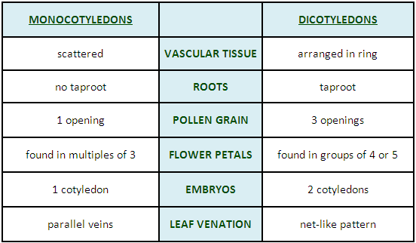

10:Xylem= brings water up from the roots to the leaves.
Phloem= transports solutions and nutrients throughout the plant.

12:Mosses, Liverworts, and Hornworts
13: Club Mosses, Horsetails, Ferns

