The Movie Production Process
For over a century, the movie industry has developed and perfected its craft. In that time, it has created an effective process for producing products ranging from movie trailers and short features to major summer blockbusters. The movie production process is a good model for creating a movie, TV show or video.
Understanding the basics of the production process is helpful even when creating a video on your own. While you will not have a large movie crew to individually handle the many separate roles, many of those jobs will still have to be done. Understanding when and how they are done in a movie production can help you plan your own work in your own production.
- Pre-production
At this stage, an idea is developed. The director oversees the writers as they create the scripts and screenplays, and the producer arranges budgets and finances. Every movie or video begins with an idea. Some are based on novels; others are borrowed from history, a personal experience or even another movie. The producer has the job of raising funds and hires a crew to produce the final product. The producer also ensures that legal issues about the rights to the story are settled. Funding can come from various sources, including private investors (e.g., individuals, groups or banks), government grants and gifts from Arts foundations. Before fundraising begins, the producer requires the movie or video to be described in detail from beginning to end. This is used in the proposal for the project, and includes the project's treatment (how it will be created and presented). During this stage, plans and preparations are made for music and special treatments (e.g., sound, lighting, technical effects). A storyboard is created to communicate the plans for each scene to the production crew. You will read more about storyboards on the next page.
- Production
This is where the actual creation of the movie happens. The sets are built and cameras record more than enough footage to turn into a final movie. At this state, the director is extremely important. He or she is in charge of translating the plan for the movie into reality, making sure that all the necessary footage is captured and meets the movie's style and treatment requirements. The director ensures that the actors and camera operators understand and follow the artistic vision for the movie, as well as the technical requirements.
- Post-production
Once production is complete and all possible scenes have been recorded to video or film, the third and final stage begins. At this stage, the unedited and untouched images (the "raw" footage) are reviewed, organized and manipulated to get the desired storyline and effect. Effects that could not be managed when filming actors on the set can now be added to the video or film. The editor screens all of the footage, throwing aside any scenes that do not add to the story or that would make the final product too long. The editor assembles only the best scenes into the final sequence that we will see
- Distribution
This is the stage that delivers a completed movie to the viewers. It may be released in stages, beginning with a preview at a release party, followed by an appearance at a film festival. The goal is generally a mass release through cinema box offices, or directly to DVD, Blu-ray or a TV network like Netflix
.

Storyboarding

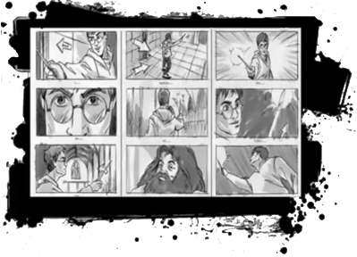
The process of turning an idea into a final movie or video can be very complex. Depending on the size of the project, the number of people involved and the variety of roles they fill, the crew can range from small to massive. Communicating ideas and plans from one person or team to another and from the pre-production stage to the production stage is a serious challenge. These communications are not terribly different from describing a dream to someone who will then leave the room and build a model to represent it. The chances of misunderstandings and different visions are high.

The most effective method for describing and communicating plans for any kind of video production is a storyboard that includes sketches of the scenes. A storyboard is like a comic strip that describes everything that a production crew requires to create the final product. Titles for the production and the scene, characters, timing, lighting, dialogue and descriptions of the action are all included, along with sketches of the scene. Including sketches in the storyboard minimizes the chances of misunderstandings. They also provide quicker, more effective information to crew members such as camera operators and stunt performers.
The storyboard is an important focus during planning, when changes are easy and affordable to make. The storyboard is developed, changed (perhaps many times) and refined until it is ready for production to begin.
Click here to watch a good video introduction to storyboards.
While we generally think of a storyboard as a communication tool for a crew or team to use, it can also be a valuable tool for a one-person video-production project. A good storyboard enables you to organize and visualize your ideas. I can help you stay within time limits, and refine your plans before actually collecting or recording images. A storyboard does not limit you, it actually provides support so you can analyze and build on your vision.

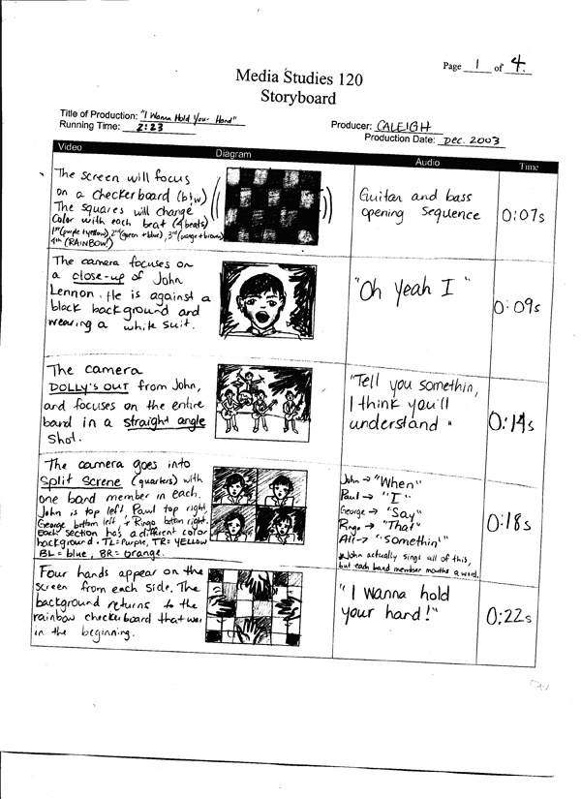

You can find different styles of storyboard online, and various templates for creating your own storyboard. So long as you include the essential information for your particular project, any style will do.

