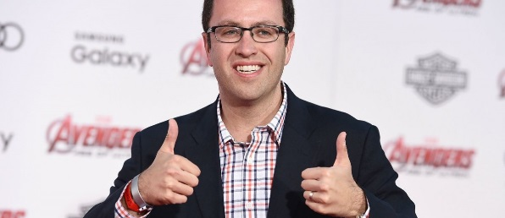
Jared Fogle reveals how he lured kids in secret recordings

CBS News October 29, 2015, 7:07 AM

New evidence that led investigators to the arrest of former Subway Spokesman Jared Fogle is surfacing, and they're in his own words.
Fogle was indicted on child porn and child sex charges in August. He has accepted a plea deal and is awaiting sentencing.
Fogle was secretly recorded by a woman who had befriended him and then became an FBI informant, reports Vladimir Duthiers of CBS News's digital network, CBSN.
The Daytime talk show "Dr.Phil" obtained the recordings and will air them Thursday. CBS News independently verified the recordings with the FBI.
In the audio recordings, being heard publicly for the first time, Jared Fogle discusses his sexual interest in children.
"I like all ages. That's the thing I mean," Fogle tells a woman in the recording. "It depends...who is ready for what. You know, who's going to give you the glance."
The woman with Fogle is Rochelle Herman-Walrond, a former radio host who interviewed him and became suspicious when she overhead him say he found middle school girls attractive.
Herman-Walrond told Dr. Phil McGraw she began providing secretly recorded conversations to the FBI, calling them "disgusting."
"I felt like I was so dirty," she told Dr. Phil. "My soul was dirty."
Fogle even details the process of how he approaches the young victims.
"We just start sharing stories, and then, you know, we get a little closer, and a little closer, and a little closer, and before you know it...it just starts to happen," Fogle told Herman-Walrond, saying it was not hard "at all."
"He talks about how to groom a family, he talks about how to groom the victim, he talks about all the things he does, the tricks of his trade," Dr. Phil said. "He just basically gives you the playbook of an evil monster."
Fogle became a household name as a pitchman for Subway, and used his fame to establish a foundation promoting healthy lifestyles among children.
In August, Fogle pleaded guilty to one count of distributing and receiving child pornography and one count of crossing state lines to engage in illicit sex with minors. He will be sentenced in November.
Subway cut ties with its spokesman following his arrest. In September, the chain said Hermand-Walrond made a serious complaint about Fogle in 2011, but that it had been mishandled.
After amassing five years-worth of recordings, Herman-Walrond finally reached her breaking point when Fogle mentioned her two young children.
"What if we, what if we put a camera in your kids' room, would they be okay with that?," he asks her in the recording. "Would you rather have it in your son or your daughter's room? Which one do you think would be better?"
Dr. Phil said Herman-Walrond had to distance herself from her kids and family for hours afterwards.
"And it took a lot of time from her family and changed who she was. That was a very painful thing for her," said Dr. Phil.
Fogle is facing five to 12 and a half years in prison and up to a $500,000 fine. His attorney declined to comment.
Subway told "CBS This Morning" they have not heard the tapes. The company says it feels duped and betrayed by Fogle, and that its sympathies go out to his victims and their families.

Related Questions:

- Subway was made aware of the allegations against Jared Fogle in 2011, but did not cut ties with him until he was arrested on these charges this year. Does this affect your perception of the fast-food chain in any way? Explain. (Evaluation)

