ON THESE PAGES, please provide notation that shows evidence of your thinking, questioning and connecting WHILE you read (text-to-text, text-to-self, and text-to-world), along with your best attempts at figuring out unknown words in context. Then, complete the Food for Thought section at the end.

Chicken restaurant trains an actual chicken to run its Twitter account

Betty the chicken likely has no idea she's promoting the consumption of her own species
By Lauren O'Neil, CBC News Posted: Oct 16, 2015 10:20 PM ET Last Updated: Oct 16, 2015 10:31 PM ET
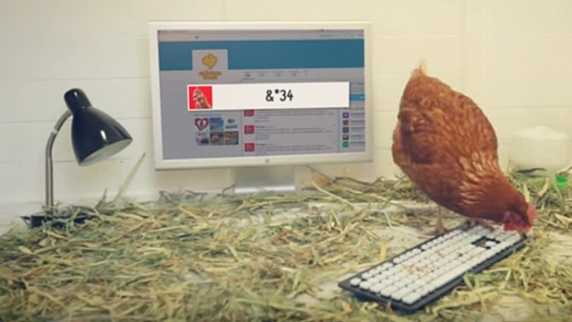
Betty the chicken tweeted her first full word on Thursday, Oct. 15. It was "bum." (Chicken Treat/YouTube)
An enterprising chicken is breaking down boundaries for hens across the world right now by going online to prove that she's more than a piece of meat.
She's also good at Twitter.
Betty is the four-year-old domestic fowl and social media marketing professional behind #ChickenTweet — a hashtag created by Australian fast food chain Chicken Treat for the exclusive purpose of documenting her recent work.
Chicken Treat
@Chicken Treat

zxqfa,ub83c bnyixpo,kughemmkywzvz........... p/eeoøt4r5f vmugm,;cfzzrcc0=pp-0;'''''''''''''''''''''''''''''''''''''''''''''---
#chickentweet
8:06 pm – 16 October 2015

While undoubtedly young for the job, and perhaps less qualified than others in her field, Betty has been doing a bang-up job of attracting people to the @ChickenTreat Twitter account since taking it over last week.
"Betty the chicken is the real deal," raves CNN of her tweets. "Unlike those imposters, who rely on human interlocutors to actually, you know, tweet, Betty's down there in Australia doing the hard stuff herself."
While Betty doesn't actually speak English (or likely even understand what she's doing,) she does write her own tweets.
According to a video published by Chicken Treat about their Betty-centric marketing campaign last week, the plucky youngster has a computer in her coop that she can use to post "whatever's on her mind."
What she appears to be using it for, however, is to peck at its keyboard when it's covered in feed and to walk over it while completing her regular chickenly duties.
She will continue to do this until she successfully sends out a five-letter-long word in English, according to Chicken Treat. This, according to the company, will earn her a spot in the Guinness Book of World Records as "the first chicken to tweet."
So far, she's only managed to type one actual word amongst the thousands of random characters she's published, and it was two letters short of what's needed for the record.
That word, tweeted on Thursday, was "bum."
Many online appear to find Betty's nonsensical updates delightful. Some animal rights activists, however, have taken issue with her employer's social media strategy.
"Chickens don't tweet they live tortured lives," reads an image one critic tweeted at the company in response to an update about Betty.
Chicken Treat, which operates 70 stores across Western Australia, replied saying that the campaign "has been approved by the RSPCA & abides by all standards regarding animal welfare."
In response to another Twitter user who called them "animal abusers," the company said "We are happy to assure everyone that Betty is well looked after and is very happy at her home at Chicken Tweet HQ."
More problematic to some people is the dark irony behind having a chicken run a Twitter account that promotes the consumption of her own species.
As TIME Magazine puts it, "Betty is unwittingly working to promote a firm that exists only to execute and barbecue her brethren for human consumption."
Betty may or may not have spoken out on the issue herself using the @ChickenTreat Twitter feed. We don't speak chicken, so it's hard to say.
Whatever the hen is tweeting, however, it appears as though she's making an impact among her fellow fowl — as well as some fans.

Food for thought:
- What is the primary motive behind Chicken Treat’s having Betty the Chicken produce tweets? (understanding)

- What is the primary motive behind a regular person’s retweeting Betty’s tweets? (analyzing/applying)

- Look back at the text in bold italics. Considering the quote, give a good try at developing your own definition of the word irony:

