- THOUGHTFULLY PROVIDE NOTATION ON THIS ARTICLE TO SHOW EVIDENCE OF YOUR THINKING THROUGHOUT YOUR READING (text-to-self, text-to-text, text-to-world, and vocab strategies).
- RESPOND TO THE “Food for Thought” SECTION BELOW THE ARTICLE.

'9/11 babies' turn 14 today, do good deeds in New York

Teens born on Sept. 11, 2001 mark their birthdate by paying tribute through volunteering, fundraising
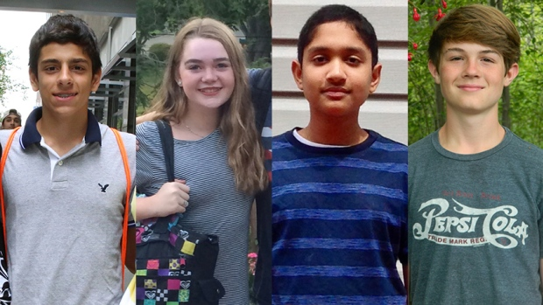
Trevor Namas, Hillary O'Neill, Anish Shrivastava and Jake Tomlinson, who were born on Sept. 11, 2001, are taking part in 9/11 Day, a project that encourages good deeds to pay tribute to the compassion that arose in the immediate aftermath of the 9/11 attacks.
Some of them have just started Grade 9. Some have grown so tall their mothers now look up at them. More than a few are learning to play guitar. And some will flash a mouthful of braces when they grin.
To a world that greeted them 14 years ago amid the worst U.S. tragedy since Pearl Harbor, they were known as the "9/11 babies." But they're babies no more.
The young adults born on Sept. 11, 2001, represent the promising new lives that arrived at a time when humanity was gripped by heartache, anger and confusion following a series of co-ordinated attacks on the U.S.
Today, on that tragic anniversary, an estimated 13,000 American teens will celebrate their 14th birthdays.
Among them will be Trevor Naman, Hillary O'Neill, and Anish Shrivastava a few of the young faces of 9/11 Day, a global campaign that promotes charitable engagement and good deeds to memorialize the goodness that pulled the world together following the Sept. 11 attacks.

Travelling to Manhattan
Trevor's mother, Christine, was already in labour in a Pennsylvania hospital that day 14 years ago as the hijacked American Airlines Flight 11 struck the North Tower of the World Trade Center shortly before 9 a.m. ET.
Just an hour west of her hospital room in Monroeville, Penn., United Airlines Flight 93 crashed into a field in Shanksville, Penn. at 10:03 a.m.
Trevor was born at 2:07 p.m. Now a six-foot-tall hockey and football player with a firm handshake, he stands an inch shy of his father, Peter.
This year, his family travelled to Manhattan from Monroeville so Trevor and seven others sharing the same birth date can help ring the opening bell at the New York Stock Exchange, part of a kick-off event for 9/11 Day. (The kids will receive a surprise birthday cake.)
Along with Hillary and Anish, Trevor will also be volunteering with New York's City Harvest food rescue program.
"When people hear about my birthday, it's like, 'Wow!' They're amazed. But it's not really weird. I think it's a good thing to have a birthday on this day. It gives me a reason to be different," Trevor says. "9/11 Day is like about helping out the community."

'Turn the TV off'
As with Trevor's mother's experience, Heather O'Neill was going into contractions the morning of Sept. 11, 2001, as televisions in her Connecticut hospital room flickered images of the Twin Towers burning.
"It was probably around 11 a.m. when Heather finally requested they turn the TV off," her husband, Glenn, recounted. Their daughter, Hillary, was born at 2:55 p.m.
A sunny Ninth Grader in Norwalk, Conn., Hillary loves to read and sing along to Vance Joy and Taylor Swift. She works as a camp counsellor.
This summer, she set up a neighbourhood lemonade stand to raise funds for Al's Angels, a local charity helping children with cancer.
"Being born on Sept. 11, it sort of made me live in the moment, because anything bad can happen," she says. "It's almost shaped who I am."
Those who learn about Hillary's birth date for the first time often react the same way.
"A lot of people, when they hear I was born on 9/11, it brings smiles to their faces because they realize that something very bad happened that day, but it was also a day when some good things happened."

Taking off 9/11 to visit a newborn
Anish Shrivastava, who turns 14 today, shares a birth date with an estimated 13,000 Americans. His uncle, who worked in the World Trade Center in 2001, decided not to go to work on Sept. 11 so he could meet his newborn nephew at a hospital in New Jersey. (Jaya Shrivastava)
One of the most remarkable stories was that of Anish Shrivastava, whose uncle worked inside the World Trade Center, but decided to take the day off on 9/11 so he could meet his newborn nephew.
Anish, a voracious reader, guitarist and Xbox gamer, was born at 10:05 a.m. in New Jersey.
"We always think that Anish came to save his uncle, and they share a very special bond," says Anish's mother, Jaya. "And Anish just says, 'I really didn't have anything to do with it, mom, it was just by chance that I was born.”

Symbolizing hope
That's a key takeaway for 9/11 Day, said David Paine, who co-founded the charity a few months after the 2001 attacks.
"The kids symbolize hope. At the very moment this terrible event was occurring and people were dying, there were all these children being born," Paine said. "They came to the world with hope and kindness and innocence. These children are representatives of the future, and they symbolize the side of goodness and how everybody came together on the day of that tragedy."
While the kids will be on a televised media tour in Manhattan with Fox and Friends, and possibly CNN, it's also important to have some perspective on the day, Hillary O'Neill's father, Glenn, says.
"One thing that kind of gets lost a little bit is, I kind of have to remember, hey, she's a 14-year-old girl and it's her birthday!" he said. "As much as Hillary is very excited to be a part of everything and help make a difference, at the end of a day, I think she'd like to get home, eat some cake and open some presents."
Food For thought questions (Please answer on the back of the sheet)
- What do you think is the purpose of the words that are in bold print? ( analyzing/applying)

- Do you agree that the creation of this charity was a good idea? Explain (evaluating)

