U.S. county clerk Kim Davis jailed for contempt over same-sex marriage licences

Kentucky judge says fines won't persuade her to issue marriage licences
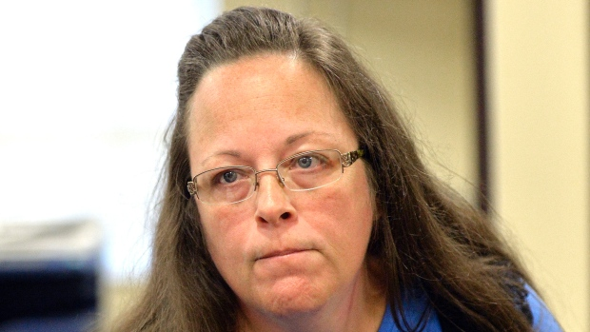
The Associated Press Posted: Sep 03, 2015 3:29 PM ET Last Updated: Sep 04, 2015 1:17 PM ET

Kentucky county clerk Kim Davis has been sent to jail over her refusal to issue same-sex marriage licences. (Timothy D. Easley/Associated Press)
A defiant county clerk in Kentucky was sent to jail for contempt Thursday after insisting that her "conscience will not allow" her to follow a federal judge's orders to issue marriage licences to same-sex couples.
"God's moral law conflicts with my job duties," Kim Davis told U.S. District Judge David Bunning. "You can't be separated from something that's in your heart and in your soul."
The judge said she left him with no alternative but to jail her, since fines alone would not change her mind. A deputy escorted her out of the courtroom, although not in handcuffs, to be turned over to the custody of federal marshals.
"Her good faith belief is simply not a viable defence," Bunning said, noting that allowing an individual's beliefs to supersede the court's authority would set a dangerous precedent.
"I myself have genuinely held religious beliefs," the judge said, but, "I took an oath."
"Mrs. Davis took an oath," he added. "Oaths mean things."
Hundreds of people chanted and screamed, "Love won! Love won!" as word reached the duelling crowds outside.
The judge also told all five of the clerk's deputies, including her son, Nathan Davis, that they are free to issue licences to all applicants while Davis is held in contempt, but would also face fines or jail if they refuse to comply. He told them to meet with lawyers briefly and consider their fates before returning to his courtroom later Thursday to reveal their decisions.
A lawyer for Davis, whose defence is funded by the Liberty Counsel, a religious freedom group, argued that the deputy clerks cannot issue licences against Davis's authority, but the judge overruled this objection.

'I promised to love Him'
Before she was led away, Davis told the judge that she can't comply with the U.S. Supreme Court's ruling legalizing same-sex marriage nationwide, because it conflicts with the vows she made when she became a born-again Christian.
"I promised to love Him with all my heart, mind and soul because I wanted to make heaven my home," Davis said during about 20 minutes of emotional testimony. She described how she became a Christian and said she is unable to believe anything else.
April Miller, who was denied a licence four times at the clerk's office, also testified. She said she voted for Kim Davis last year and that she has no desire to change the clerk's personal beliefs.
Outside, demonstrators shouted at each other, sang hymns and waved signs, which ranged from the violent — turn to Jesus or burn — to simple statements of support. A small plane flew over the courthouse, carrying a banner that said: "Stand Firm Kim."

Married 4 times
Davis, an Apostolic Christian whose critics mock her for being on her fourth marriage, stopped issuing licences to all couples after the Supreme Court ruling, and the courts have consistently ruled against her since then. But many supporters have rallied around her, including Republican presidential candidate Mike Huckabee, who called her personally the day before.
"People are calling the office all the time asking to send money," she testified. "I myself have not solicited any money."
Davis said she hopes the legislature will change Kentucky laws to find some way for her to keep her job while following her conscience. But unless the governor convenes a costly special session, they won't meet until next year. "Hopefully our legislature will get something taken care of," Davis told the judge.
Until then, the judge said, he has no alternative but to keep her behind bars as long as she refuses to follow the law.
"The legislative and executive branches do have the ability to make changes," Bunning said. "It's not this court's job to make changes. I don't write law."
Davis served as her mother's deputy in the clerk's office for 27 years before she was elected as a Democrat to succeed her mother in November. As an elected official, she can be removed only if the legislature impeaches her, which is unlikely in a deeply conservative state.
Related Questions:

- What is main idea of this article? (Comprehension)

- Do you agree that sending Kim Davis to jail was the appropriate course of action to take in this situation? Why or why not? (Evaluation)

